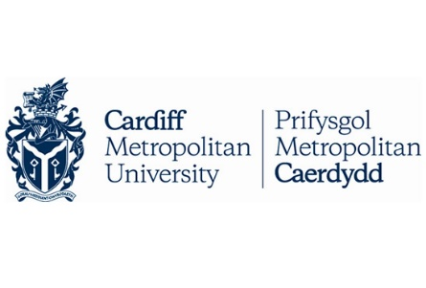

**Assignment Cover Sheet**

|  |  |  |  |
| --- | --- | --- | --- |
| **Qualification** | | **Module Number and Title** | |
| HD in Computing and Software Engineering | | CSE5013 Service Oriented Computing | |  |
| **Student Name & No.** | | **Assessor** | |
| Chameera Kavinda Senarathna KD/HDCSE/CMU/64/12 | | Gihan Herath | |
| **Hand out date** | | | **Submission Date** |
| 17/05/2024 | | | 12/07/2024 |
| **Assessment type**  Coursework | **Duration/Length of**  **Assessment Type**  Practical project/report | | **Weighting of Assessment**  **100%** |

|  |  |
| --- | --- |
| **Learner declaration** | |
| I Chameera Kavinda Senarathna KD/HDCSE/CMU/64/12 certify that the work submitted for this assignment is my own and research sources are fully acknowledged. | |
| |  |  |  |  | | --- | --- | --- | --- | | **Marks Awarded** | | | | | First assessor | |  | | | IV marks | |  | | | Agreed grade | |  | | | Signature of the assessor |  | Date |  | |

**Feedback Form**

**International College of Business & Technology**

**Module:** Service Oriented Computing

**Student:**

**Assessor :**

**Assignment:**

**Feedback:**

**Marks Awarded:**

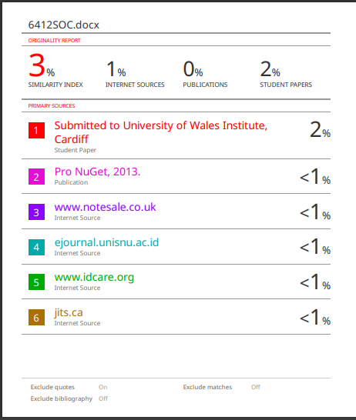

Table of Contents

**Acknowledgement** 5

**Executive Summary** 5

**Task 01:-** 6

**Monolithic Architecture** 6

**Advantages:-** 6

**Disadvantages:-** 7

**Service-oriented architecture (SOA)** 7

**Advantages:-** 7

**Disadvantages:-** 8

**Comparison of Monolithic Architecture & Service-Oriented Architecture** 8

**Excellent Architecture for Scalability and Maintainability:-** 8

**Conclusion** 10

**Task 02:-** 11

**Architecture diagram:** 11

**Use Case diagrams** 12

**Activity diagrams:-** 18

**Class diagram:-** 26

**Development of a SOC based Event Management System to Debra Events.** 27

**Task 03:-** 56

**Testing of the API** 56

**Testing the Client Application:** 72

**Test Result:-** 96

**Task 04** 97

**1.** **Traditional Server Deployment** 97

**2.** **Docker** 98

**3.** **Kubernets** 99

**Comparison with other deployment techniques mentioned** 100

References 101

# **Acknowledgement**

On this great occasion of successful completion of my assignment, I would like to thank our lecturer, Mr. Gihan Herath who has guided and assisted me to complete this assignment. Without his support, I would not have completed the assignment on time.

Finally, I would like to thank my friends and family, without them this assignment would not have been completed effectively in a short time.

# **Executive Summary**

This project provides a Service-Oriented Computing solution for Debra, a leading event management company in Singapore, to streamline and expand their ticket-selling process. By integrating with entertainment businesses, social media platforms, and mobile apps, the system allows partner registration, event creation, ticket management, and sales monitoring. Debra can view comprehensive sales details, including varying commission rates per event, while partners manage their specific event sales. Implemented in C# using Visual Studio, the solution enhances market reach and operational efficiency, positioning Debra for continued success in the entertainment industry.

# **Task 01:-**

## **Monolithic Architecture**

* Monolithic Architecture and Service Oriented Architecture are the notable architectonic models, which possibly can be utilized in software development. With all the above information shared, there are also different models of software development that serve various purposes for programs to be developed as a final product.A traditional model that is trivial to understand about (Monolithic architecture) where an entire application needs a single unit of build mode. This model was a monolithic style where all components of the system from business logic to data access component are tied together and runs as a single service (D. & Dmytro H., 2019).

**Use to the Debra**

This kind of "monolithic" approach for Debra's event management system, could be a hint that there is one application doing all tasks from partner registration to ticket sales and income summary. This is going to be single application, which internally have modules for all need, and theses are deployed & work in tandem.

### **Advantages:-**

* **Scalability:** If the need arises, each service can be scaled separately. Horizontal scaling is simpler to do.
* **Maintainability:** It is simpler to create, comprehend, and manage more compact, well defined services. Teams can operate separately on various services.
* **Flexibility:** Different technologies can be used to create services, and they can develop and change on their own.
* **Resilience:** System failure is not always the result of a single service going down. By using fault tolerance techniques, services can be strengthened.

### **Disadvantages:-**

* **Complexity:** Different application components cannot be scaled separately because the additional resources are based on a single server caused by scaling.
* **Lateness:** Compared to in-process calls in a monolithic program, network calls between services can cause latency.
* **Deployment:** No matter how well your deployment process works, it will always require redeploying the entire application whenever you make a change, even if it is minor enough to be fixed with a single file edit. This increases the possibility of problems and downtime.

## **Service-oriented architecture (SOA)**

SOA refers to an architectural pattern in which an application consists of loosely coupled services. Each service has one clear focus (a single business capability), and it interacts with other services through a specific set of interface messages over various network protocols such as HTTP/HTTPS or through standardized formats including SOAP or REST. SOA makes it easy for software components in different networks to communicate with each other (D. & Dmytro H., 2019).

**Use to the Debra**

For Debra management partner registration, event administration, ticket management and reporting in this case study, separate services will need to be created. Each service is developed, implemented and scaled separately.

### **Advantages:-**

* **Scalability:** Here horizontal scaling is easier to achieve. Each service can scale independently based on its demand.
* **Maintainability:** Smaller, focused services are easier to write and understand Services can be developed by different teams.
* **Flexibility:** A service can be developed with other technology and evolves on its own.
* **Resilience:** If one service fails, the entire system does not go down. Services can be more robust with fault tolerance mechanisms.

### **Disadvantages:-**

* **Complexity**: increased complexity in handling transactions, data consistency, and inter-service communication.
* **Lateness:** Compared to in-process calls in a monolithic program, network calls between services can cause latency.
* **Deployment:** Overhead related to deployment, monitoring, and management of services, etc.

## **Comparison of Monolithic Architecture & Service-Oriented Architecture**

|  |  |  |
| --- | --- | --- |
| **Aspect** | **Monolithic Architecture** | **Service-Oriented Architecture** |
| **Development Speed** | Simpler design leads to faster initial development. | Slower initially because to the intricacy. |
| **Deployment** | The entire application must be reused to make changes. | Not necessarily so. A single service can be deployed. |
| **Scalability** | Limited to vertical scale. | Supports horizontal scaling of individual services |
| **Maintainability** | Maintenance becomes more difficult as the application grows. | Easy to maintain. |
| **Flexibility** | Less flexible | More flexible |
| **Resilience** | just one single point of failure. | Inter-service fault isolation. |
| **Performance** | Lower latency. | Higher latency due to network communication. |
| **Complexity** | Simpler architecture. | Service orchestration makes things more difficult. |

## **Excellent Architecture for Scalability and Maintainability:-**

Before choosing the final architecture between REST and SOA, we must keep in mind Debra's event management system requirements what they are expecting as good functionality with an excellent infrastructure.

**1. Horizontal Scalability:** It is important to meet load for ticket sales different than reporting on the same service.setLayoutorientation( SOA support horizontal scaling in a real context)

**2. Smaller services:** Are easier to understand and can lead a more meaningful life; is it better in health, longer lived line of code. Thus, it can be developed in parallel and delivered faster.

**3** **Flexibility:** SOA enables the use of diverse technologies and standards to integrate with a range of partners, social media sites, and mobile applications.

**4. Resilience:** If a service fails, such as ticketing, SOA minimizes the availability of the entire system based on that failure and minimum services.

**Environmental Factors and Technical Considerations:-**

* **Organizational Structure :** If Debra's IT team has cross-functional teams as part of the organizational structure then SOA fits well since it allows each team to own a service, promoting autonomy and faster development cycles
* **Technology Stack:** SOA helps to select the best technology to use for each service, which can contribute a lot in terms of performance and development efficiency.
* **DevOps:** SOA works well with contemporary DevOps practices such as CI/CD, making it easy to automate testing, deployment and monitoring.
* **Cost:** Although in many cases SOA could be more expensive on the initial stages due to its complexity and necessary infrastructure (such as API gateways, micro services etc.), however it will eventually save cost later when comparing with traditional way; a single-function service automatically scales up 20-30 services are no longer sufficient where millions of requests per minute must process.
* **Integration Requirements:** With the need to interface SOA to external business partners and other platforms, this provides standards compliance SOA to comply with a range of overall interoperability standards.

## **Conclusion**

Both models have their benefits, but for Debra's event management system, Service-Oriented Architecture (SOA) is a better option since it provides a lot more flexibility, scalability, and maintainability. Debra can guarantee the robustness, scalability, and adaptability of its system to future requirements and integrations by implementing SOA.

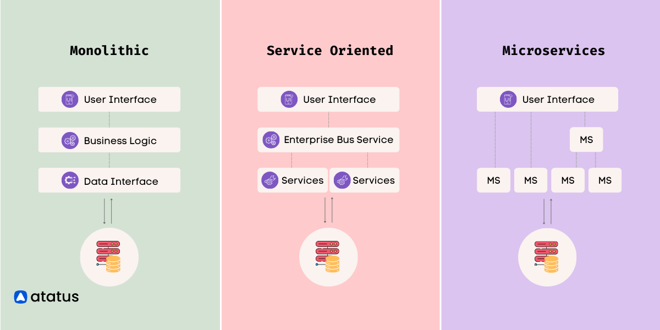

Figure 1: Monolithic vs SOA

# **Task 02:-**

To help users easily understand how the Debra Events Management software works, we need to design clear and effective diagrams. These diagrams will show the key features, use cases, and functionality of the mobile application.

To meet the main needs of the Debra Event Web Application, we can create Architecture diagrams and UML diagrams. These will include use case diagrams, class diagrams, and activity diagrams to clearly show all the important features. Here is a detailed look at how we will implement them.

## **Architecture diagram:**

We can show all the groups involved in the Debra Events management system with a detailed architecture diagram, as shown below.

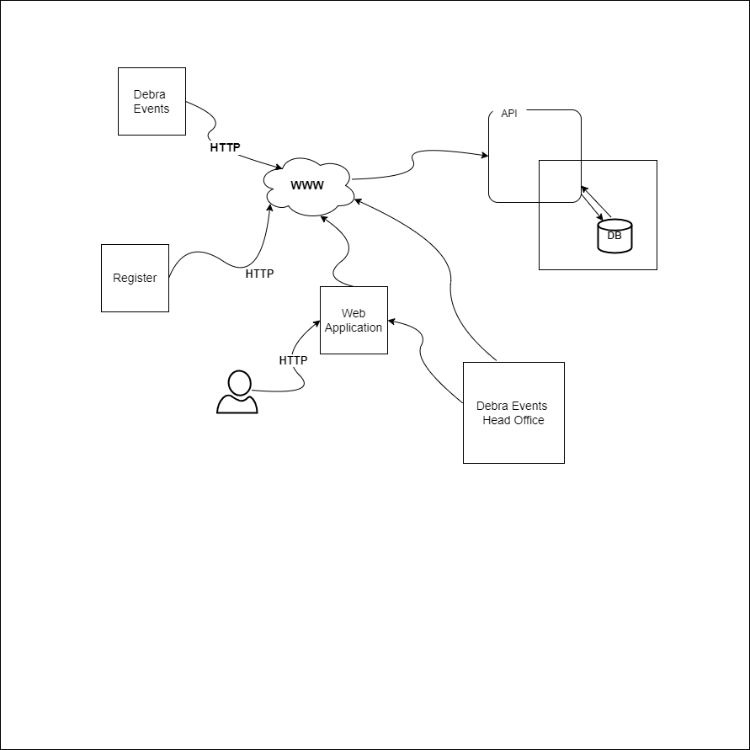

Figure 2: Architecture Diagram

## **Use Case diagrams**

Debra Management System

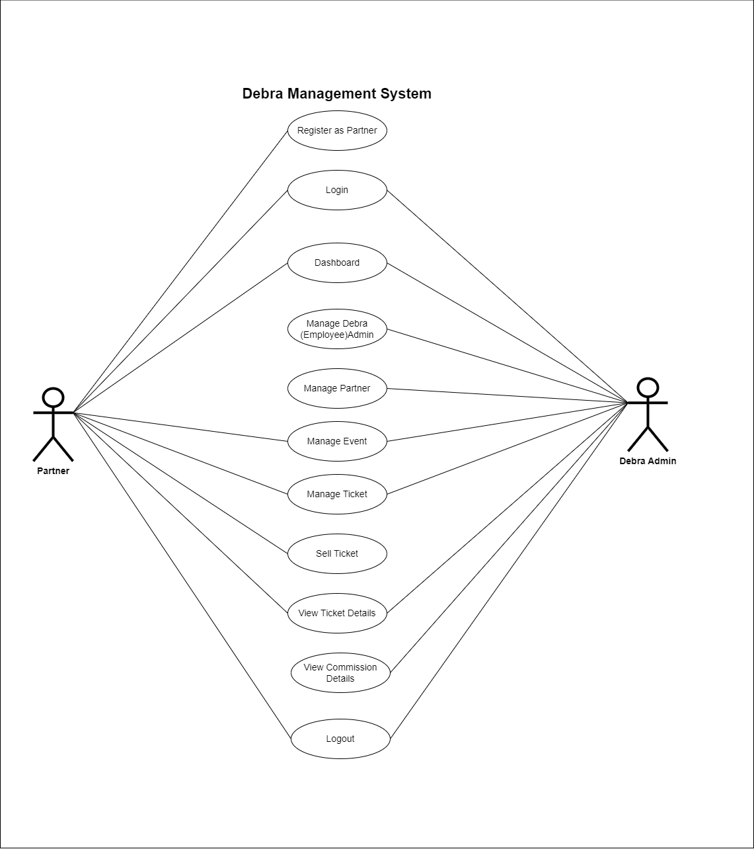

Figure 3: Use Case of Debra Event

* The use case diagram for the Debra Management System shows how two main groups, Partners and Debra Administrators, interact with the system.
* Partners can register, log in, and access a dashboard, sell tickets, view ticket details, and log out.

Debra Administrators have additional features to manage system details, including employees, partners, events, and tickets. They can also view detailed ticket and commission information and log out. This comprehensive system ensures efficient event management by providing specific functionalities for both external partners and internal administrators.

In addition, the Partner registration feature in the Debra Event Management System's Client Application can be developed using the extended use case diagram shown below.

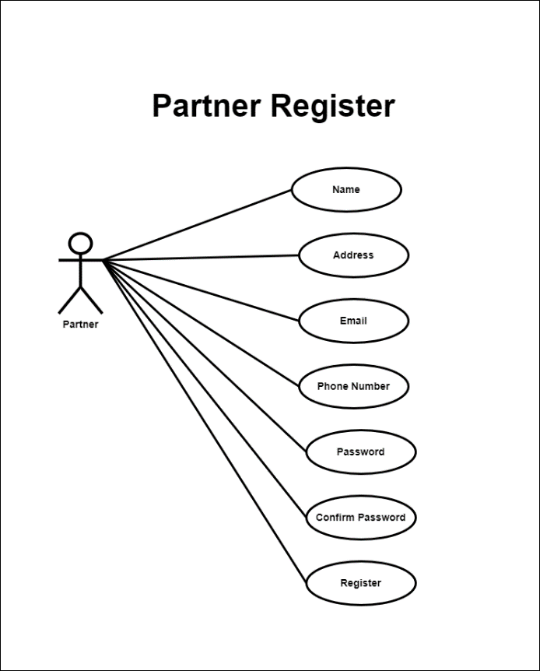

Figure 4: Partner Register

* The diagram you see is a use case diagram for a "Partner Register" feature. It shows how a user, called a "Partner," interacts with the system during registration. The partner needs to enter their Name, Address, Email, Phone Number, Password, and Confirm Password. Each of these is shown as an oval, representing the required fields. There is also a "Register" action that the partner uses to submit the form once it's filled out. The lines connecting the partner to these fields show the steps needed to complete the registration. This diagram helps ensure we gather all the necessary information from the partner, making the registration process thorough and organized.

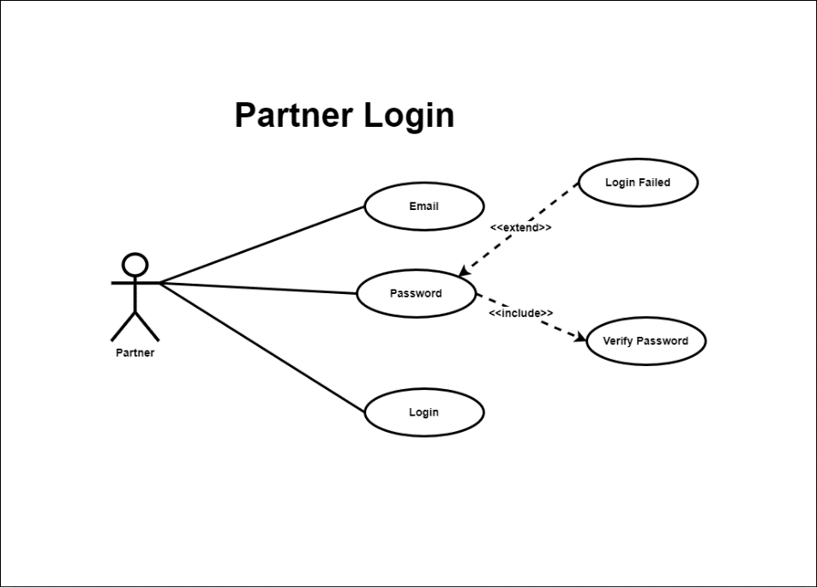

Figure 5: Partner Login

* The user, called the "Partner", interacts with the system to log in. The partner needs to enter their email and password to start the login process. There is always a "password verification" step included, which means the system always checks the password. If the password is incorrect, a "login failed" step is triggered, indicated by a "long" connection. Finally, there is the "Login" step, where the partner submits their credentials to access the system. The lines connecting these elements show the sequence of steps in the login process. This diagram helps us understand the requirements for the partner login feature and ensures that the login process includes the necessary authentication and error handling steps.

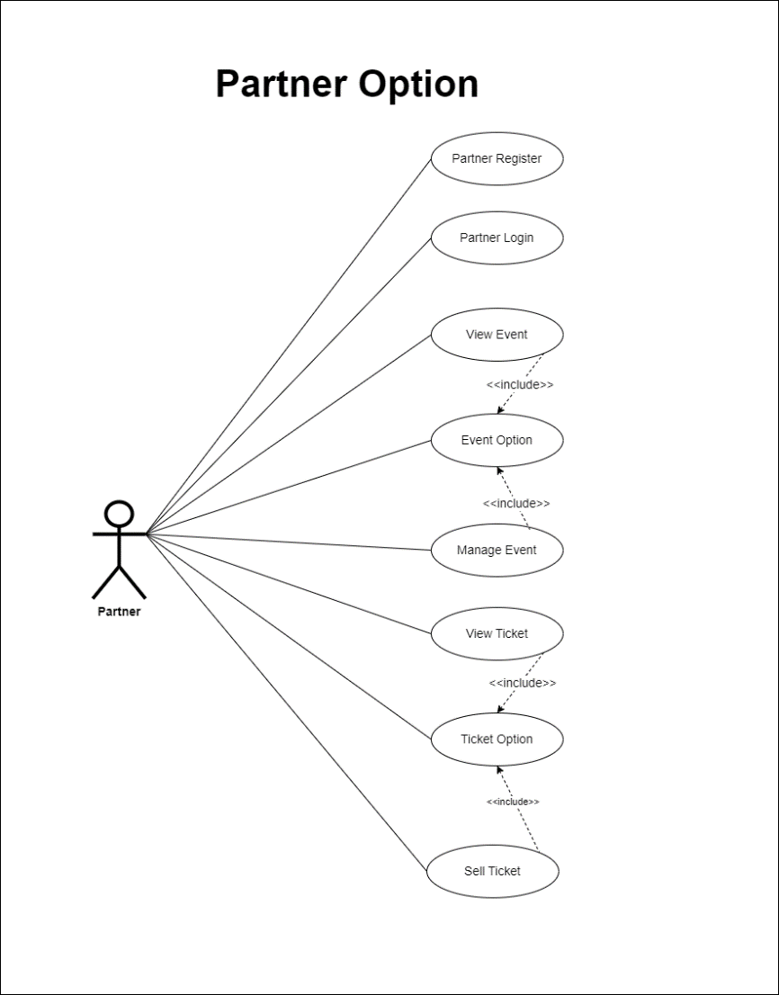**Partner Process:**

Figure 6: Partner Process

* As mentioned earlier, once a registered partner logs into the system, they will see the Event Option. Here, they can enter new events, view details of existing events, and manage them.
* Next, the partner will move on to the Ticket Option. This section provides information about tickets related to the events, including prices and the option to sell tickets. Finally, the partner can use the logout option to exit the system.

Admin Login Process:

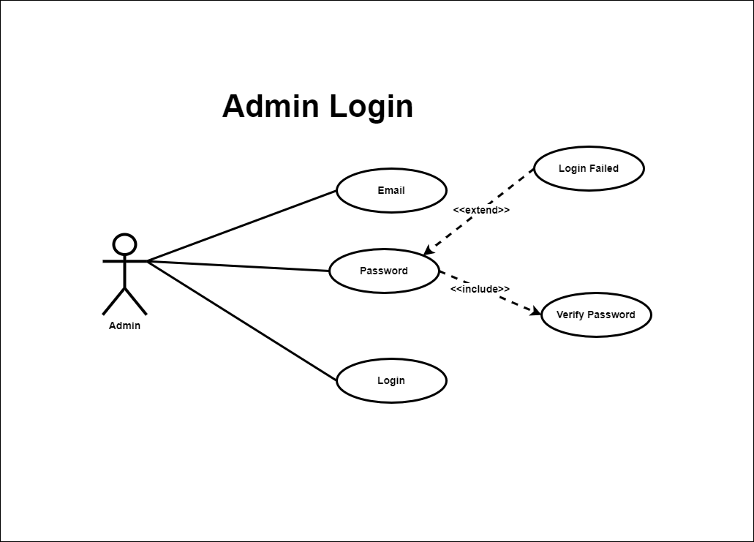

Figure 7: Admin Login Process

This diagram shows how an Admin logs into the system. It starts with the Admin entering their email and password. Once the password is entered, the system checks to make sure it is correct. If everything matches, the Admin is logged in. If not, the system shows a "Login Failed" message. The diagram highlights these steps and how they connect, making it easier to understand the login process and what happens if something goes wrong.

**Debra Admin Process:**

* This use case diagram, titled "Employee Option," shows the different actions an Admin can take within the system. The Admin is connected to several tasks, like logging in as an employee, managing other admins, managing partners, viewing and managing events, viewing and managing tickets, and viewing commissions. Each task represents a specific job the Admin can do.

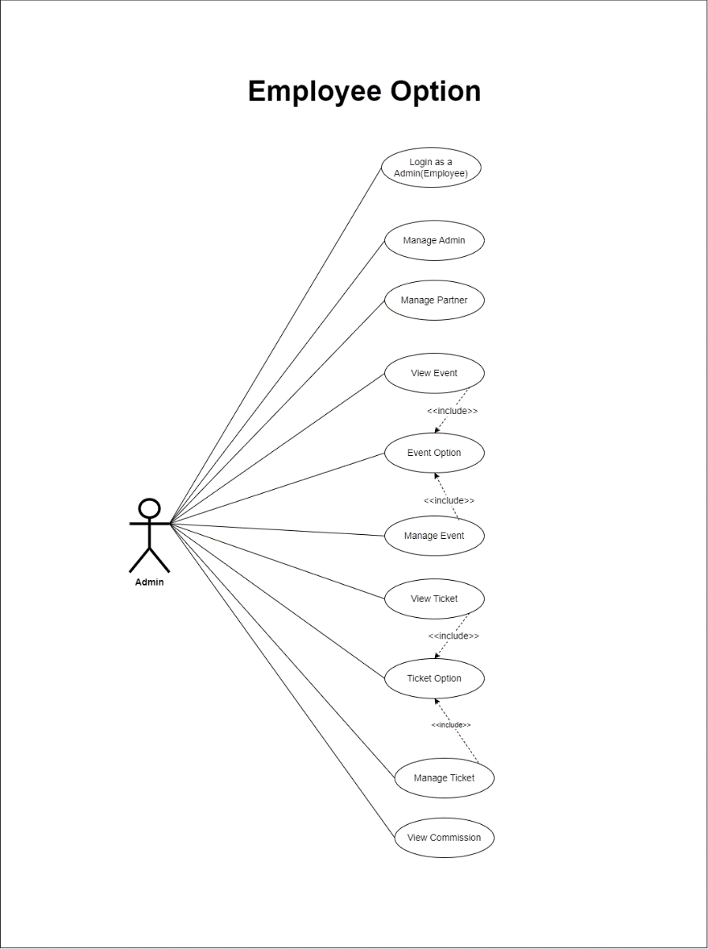

Figure 8: Employee Option

* The diagram also includes "Event Option" and "Ticket Option," which are automatically part of the event and ticket management processes. These are shown with dashed arrows and the label "<<include>>," meaning they are necessary steps within those tasks.

Overall, this diagram outlines the various administrative roles and responsibilities an Admin can handle, emphasizing how these tasks are interconnected within the system.

## **Activity diagrams:-**

Debra Event Management's web application needs activity diagrams to show how different tasks flow within the app. These diagrams help give a clear picture of all the important steps involved in completing each task effectively.

.

So, for some of the key functions in the Debra Event Management web application, we can create activity diagrams to illustrate these processes

**Partner Process**

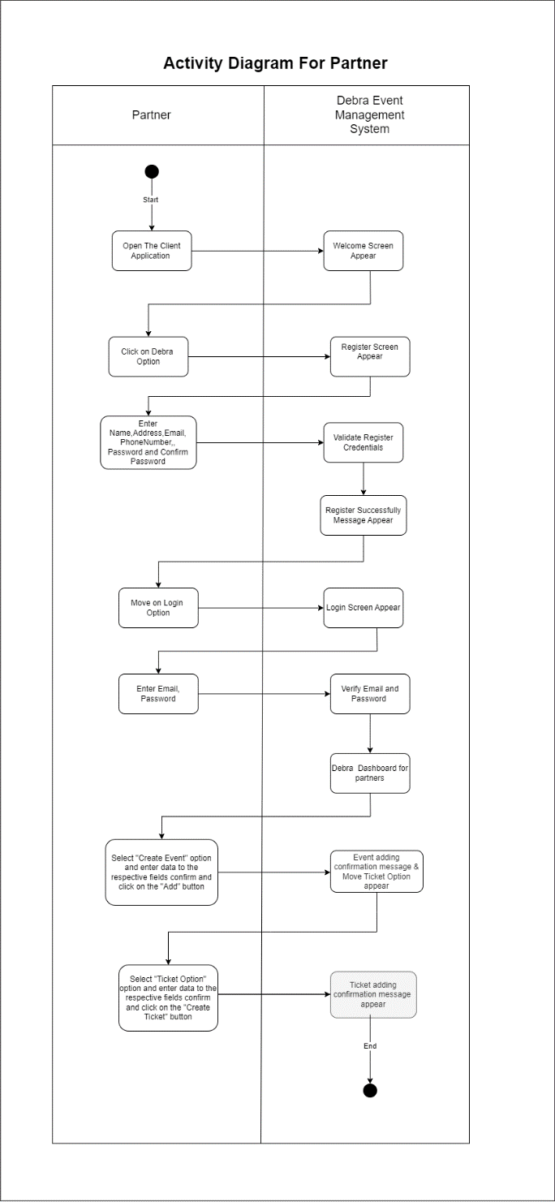

Figure 9: Partner process of Activity Diagram

All the processes related to the partner are depicted in the above activity diagram and the process within each category can be classified as follows.

**Partner Register Process:**

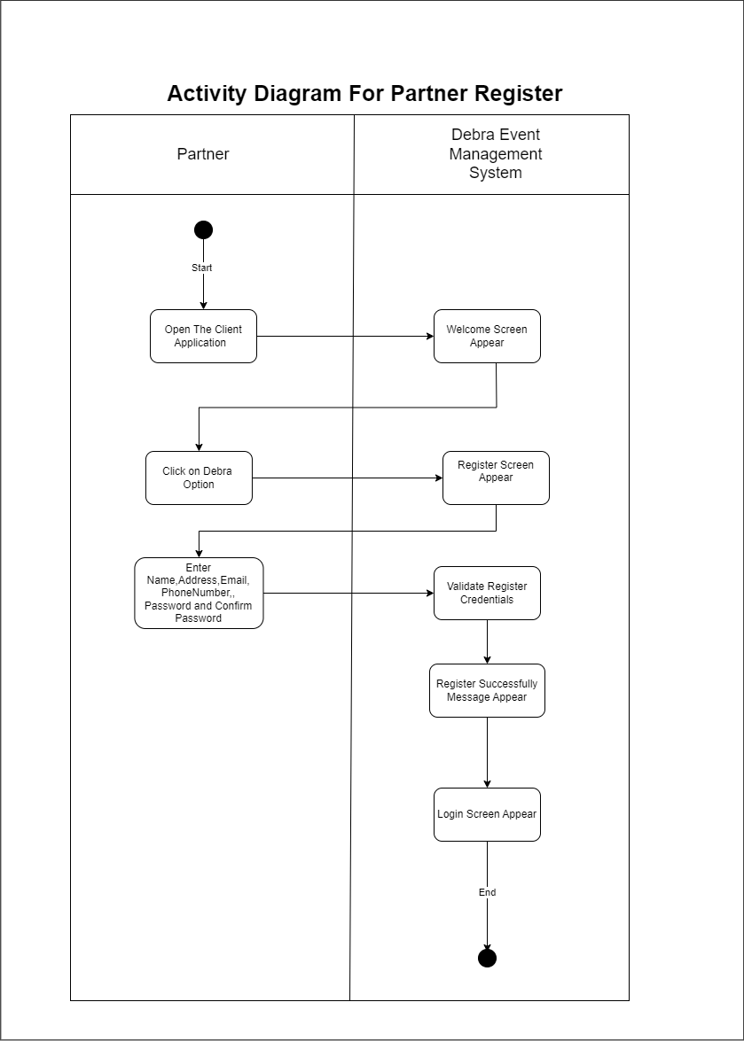

Figure 10: Partner Register Process of Activity

* The activity diagram for partner registration in the Debra Event Management System shows the step-by-step process a partner goes through to register.
* It starts when the partner opens the client application, which brings up a welcome screen.
* The partner then selects the Debra option to get to the registration screen. They enter their personal information, including their name, address, email, phone number, password, and password confirmation.
* The system checks the entered details. If everything is correct, the system displays a successful registration message and then shows the login screen.
* This process ensures that partners can register quickly and securely in the Debra Event Management System.

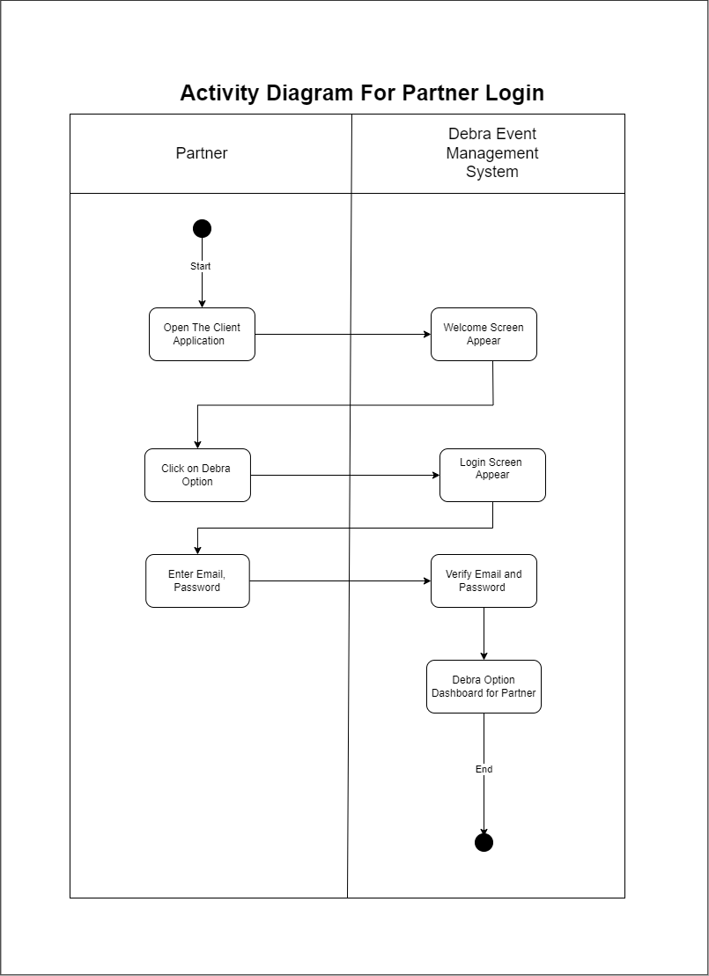**Partner Login Process:**

Figure 11: Partner Logging Process of Activity

* The activity diagram for partner login in the Debra Event Management System shows the steps a partner takes to log in.
* It starts when the partner opens the client application, bringing up a welcome screen.
* The partner then selects the Debra option to get to the login screen.
* They enter their Email and Password, and the system checks these credentials. If they are correct, the system gives access to the Debra Option Dashboard for the partner, completing the login process. This diagram clearly shows how partners interact with the system to log in securely.

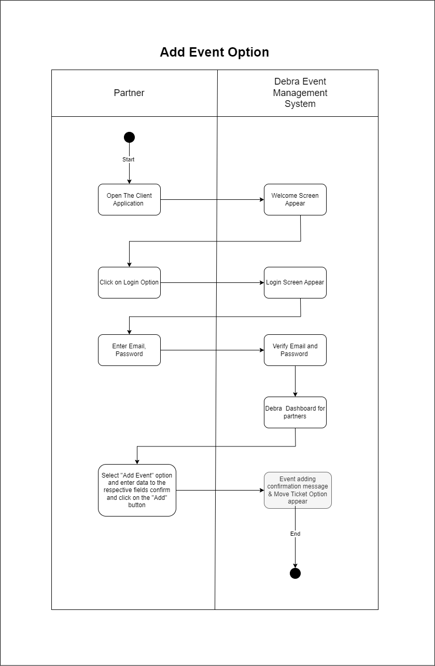**Add Events Process:**

Figure 12: Add Event of Activity

* The activity diagram for the 'Add Event' option in the Debra Event Management System shows the steps a partner takes to add a new event.
* It starts when the partner opens the client application, which brings up a welcome screen.
* The partner selects the login option, leading to the login screen. After entering their Email and Password, the system verifies the credentials.
* Once verified, the partner is directed to the Debra dashboard. From there, the partner selects the 'Add Event' option, enters the event details, and confirms by clicking the 'Add' button.
* The system then shows a confirmation message for the added event and moves to the ticket option screen. This diagram clearly shows how partners interact with the system to add new events smoothly.

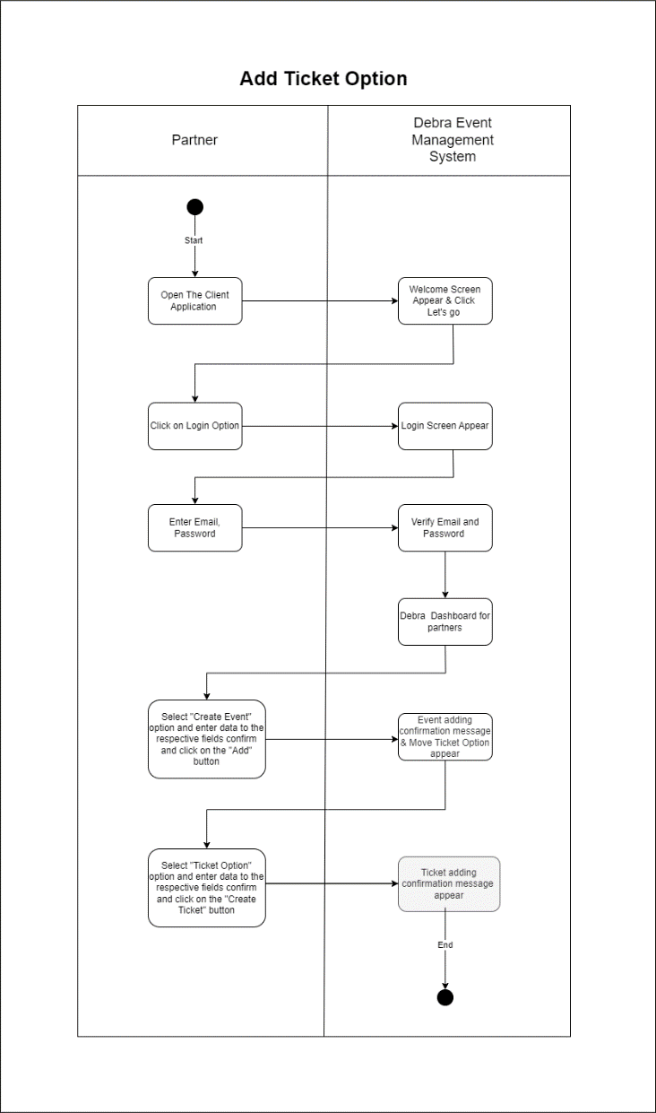**Add Tickets Process:**

Figure 13: Add Ticket Process of Activity

* This diagram shows the steps for Adding a ticket option in the Debra Event Management System, with actions divided between what the partner does and what the system does.
* First, the partner opens the client application, which brings up a welcome screen on the Debra system. The partner clicks the login option, and the system shows the login screen. After entering their email and password, the system checks the credentials and, if they are correct, lets the partner into the Debra dashboard.
* Next, the partner chooses the 'Create Event' option, fills in the event details, and clicks the 'Add' button. The system then shows a confirmation message and moves to the ticket option screen. Here, the partner selects 'Ticket Option,' fills in the ticket details, and clicks 'Create Ticket.' Finally, the system displays a confirmation message saying the ticket has been successfully added. In addition, that is the end of the process.

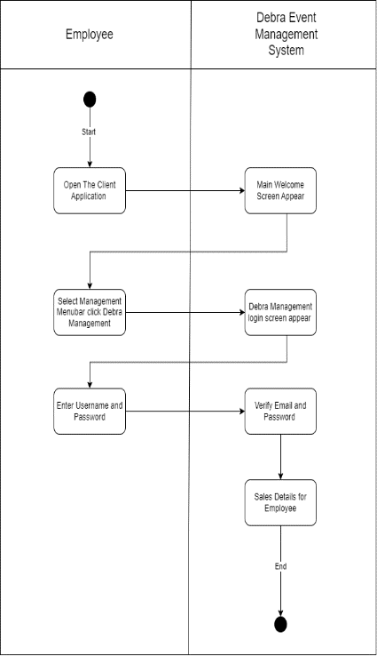**Admin Process:**

**Admin Login Process**

Figure 14: Admin Logging Process of Activity

* The party controlling the application is the administrator. Here, the employees of Debra are acting as administrators.
* This activity diagram shows how an employee accesses sales details in the Debra Event Management System.
* It starts with the employee opening the client application, which brings up the main welcome screen.
* The employee then selects the management menu bar and clicks on 'Debra Management,' which takes them to the login screen. After entering their username and password, the system checks these details. If everything is correct, the system shows the sales details, and the process is complete.

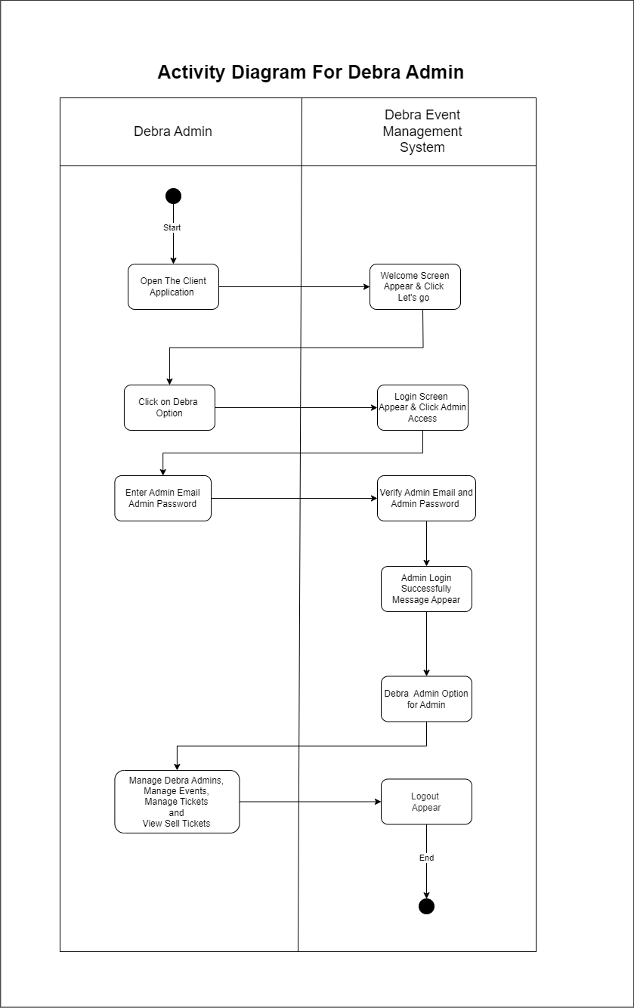

**Admin Process:**

Figure 15: Admin Process of Activity

* This activity diagram shows how Debra Admins Process into the Debra Event Management System.
* It starts with the admin opening the client application, which brings up the welcome screen.
* The admin clicks on the 'Debra' option to go to the login screen and selects admin access. Then, they enter their Email and Password, and the system checks these credentials.
* If everything is correct, the system shows a “**login success”** message and gives the admin several management options.
* These include managing other Debra admins, Managing events, Managing tickets, and Viewing sold tickets (View Commissions).
* Once the admin finishes their tasks, they can log out, ending the process.

## **Class diagram:-**

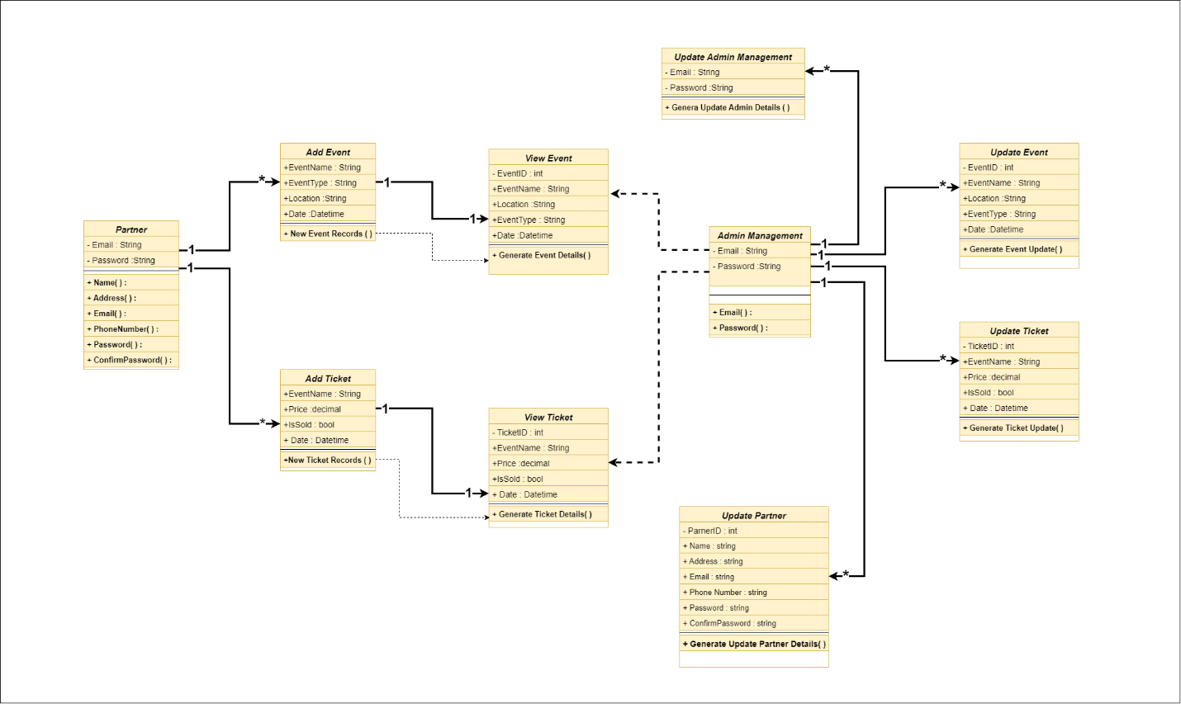This class diagram shows the properties, methods, and relationships in the Debra Event Management System.

Figure 16: Class Diagram

Before a partner registers, the value key acts as a public key. After registration, it becomes a private key.

For the relationships:

* Each partner can add multiple events (**1-to-many relationship**) and multiple tickets (1-to-many relationship).
* Each event that is added can be viewed (**1-to-1** relationship between adding and viewing an event).
* Similarly, each ticket that is added can be viewed **(1-to-1** relationship between adding and viewing a ticket).
* The administrator, who is an employee of Debra, can update multiple events, tickets, and partner details (**1-to-many** relationship for each).

## **Development of a SOC based Event Management System to Debra Events.**

* Debra Event Company wants to create an easy-to-use, computer-based event management system. This system should be user-friendly and should be able to work seamlessly with other systems.
* By creating a well-designed API and client application for the proposed Debra Events Management system, we can effectively address the mentioned issues.
* To develop the Application Programming Interface (API) and Client Application, can create codes and designs using the Microsoft Visual Studio Developer Edition Integrated Development Environment. It can also use the C# programming language to write the required code.
* For advanced development needs, Microsoft Visual Studio's developer version offers additional features including the server explorer and integration with Microsoft SQL Server.
* Additionally, the necessary APIs and the client application for Debra Event Management can be created in a Service Oriented Computing (SOC) environment. This approach allows for better scalability and advanced development features, enabling efficient modification of reusable and scalable components.

The first step is to create an ASP.NET Web API using Visual Studio. This will help us build an efficient application interface for the Debra Event system.

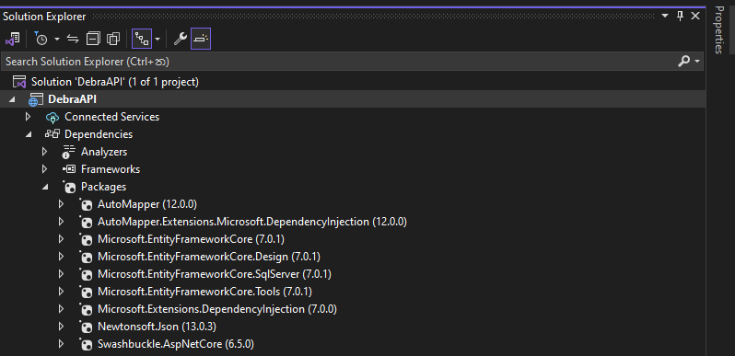To do this, you can develop the API components successfully by first installing the following packages and making the necessary connections.

Figure 17: API Packages

Furthermore, when using the API, it is important to create and access all components in the correct sequence within the designated directories.

1. Model
2. DTO
3. Profile
4. Data
5. Migrations
6. Controller

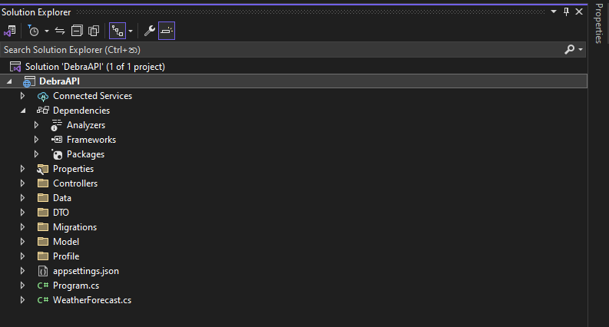

Figure 18: API Folder

* Model folder contains the necessary Classes that should be included in the API.

Figure 19: API Models

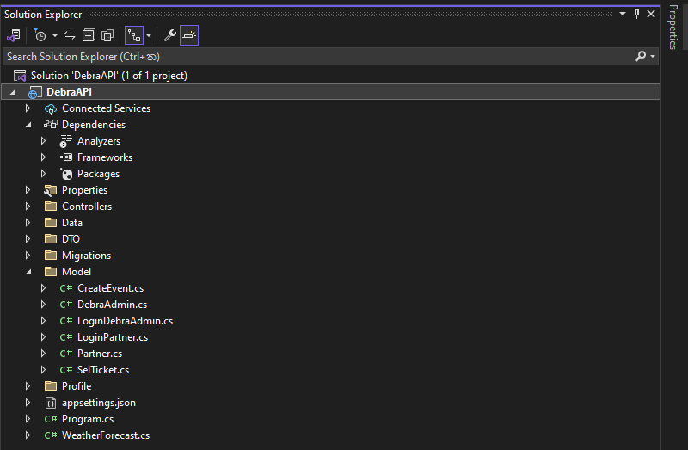

The DTO folder contains the Create DTO and Read DTO related to the classes mentioned in the Model folder above.

Figure 20: API DTO

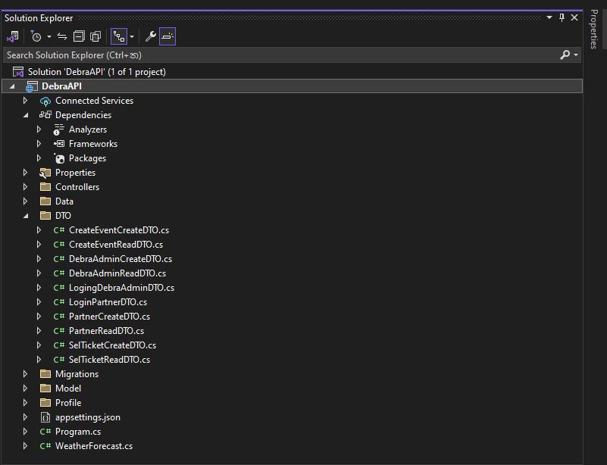

Once the DTO files are created following the correct format, the corresponding profile is then created in the Profile folder.

Figure 21: API Profile

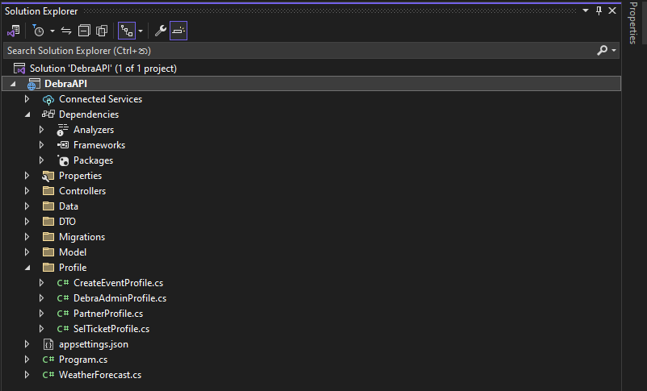

Next, for each model developed, an interface class and an appropriate class should be established, and the **DebraAppDBContext** class should be updated accordingly, including the **IRepo** and **Repo** classes that match the model. Below is the implementation of these functions performed under the data folder.

Figure 22:API Db_Context

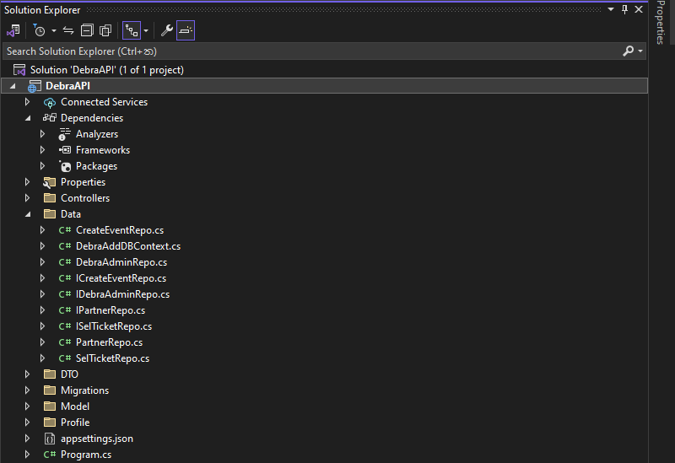

Microsoft SQL Server Management Studio is used to develop the corresponding database for the Debra Event Management System.

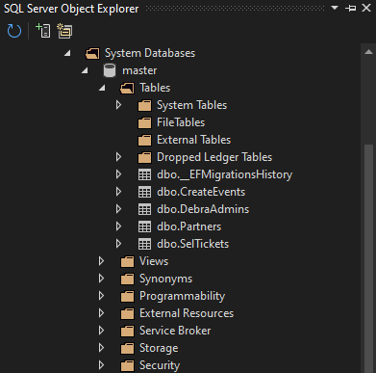

Figure 23:SQL Tables

After that, the necessary tables must be set using the models that have been built via the API. These may then be inserted as follows into the **DebraAppDBContext** file.

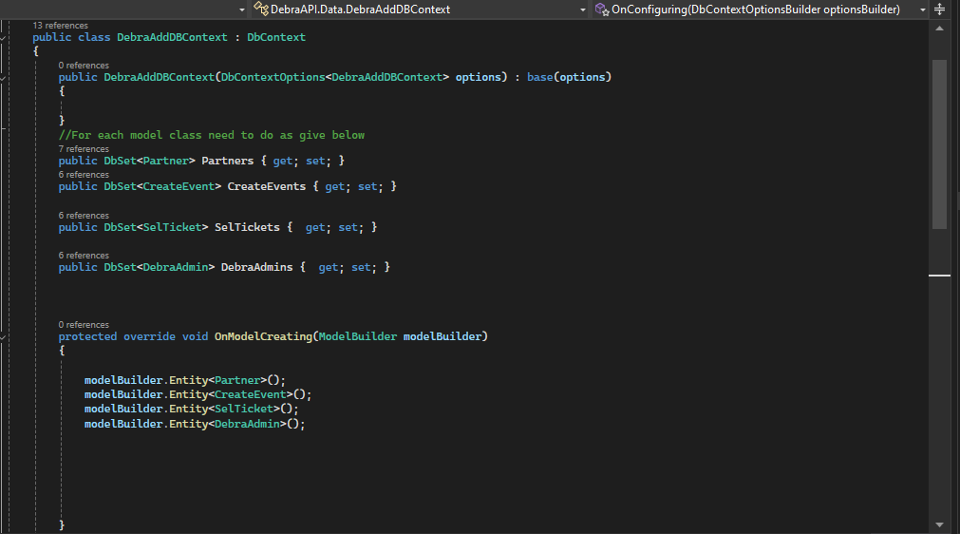

Figure 24: API Table Code

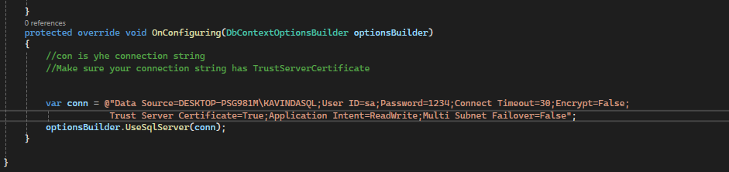The database connection string must be included in the **DebraAppDBContext** and **Program.cs** files inside the API project to successfully run and use the database.

Figure 25:Database Link

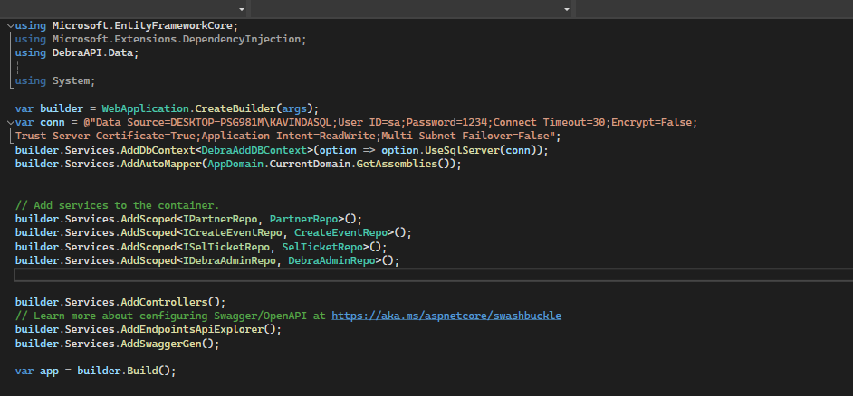

Figure 26:Dtabase Link of Program.cs

Especially after updating this data folder, it needs to **Add migrations**, which is done using the Package Manager console in Visual Studio.

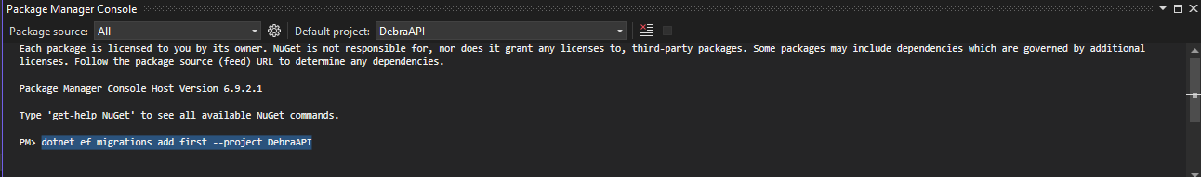

Figure 27:Add Migrations

After adding **migration**, another command can be issued to the package manager console to **update** the **database**.

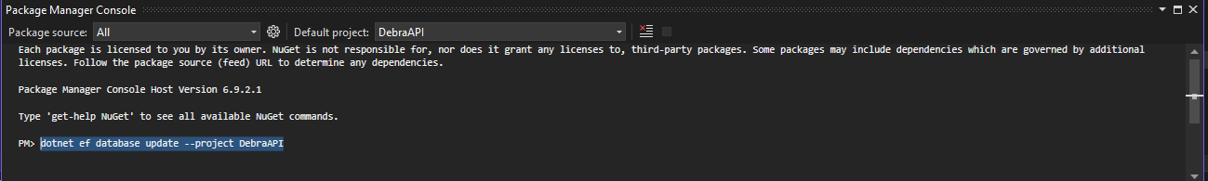

Figure 28:Update Database

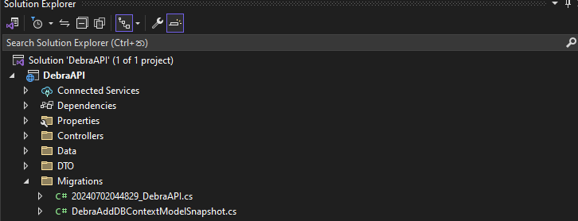All of the project's migration-related data will be saved in the migrations folder once **the Debra Event API** project has been finished in its entirety.

Figure 29:Display Migration

Ultimately, all models must have controllers implemented. The controllers that were developed after the API project was completed are listed below.

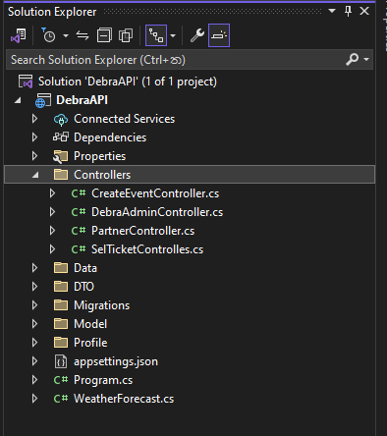

Figure 30: Controllers of API

The API will look like this in the Swagger User Interface after it has been successfully implemented and deployed with the IIS Server.

Figure 31: API

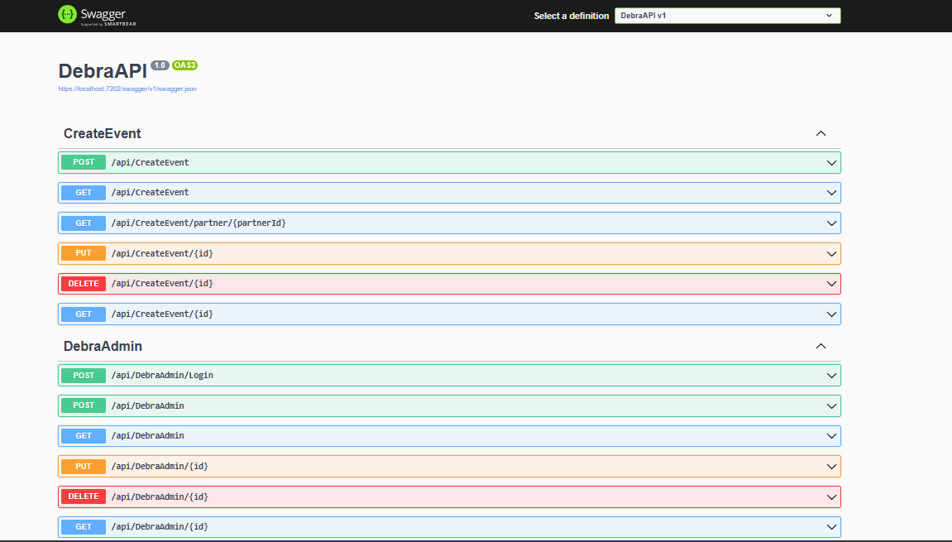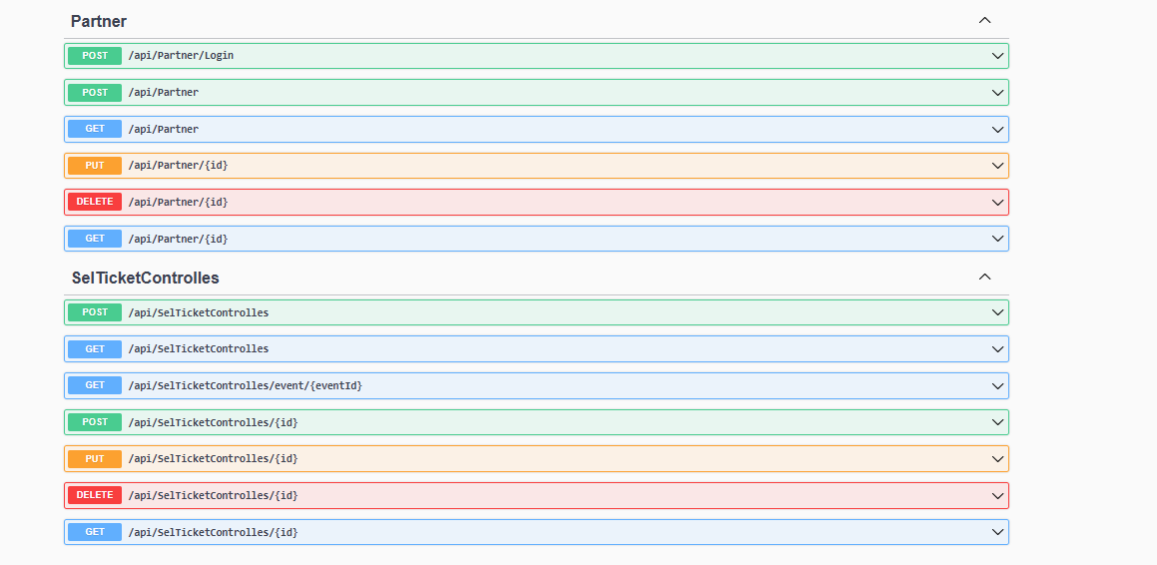

To access, insert, update, and delete data within the Debra Event Management System, correspondingly, each model within the **DebraEventAPI** will implement get, post, put, and delete methods.

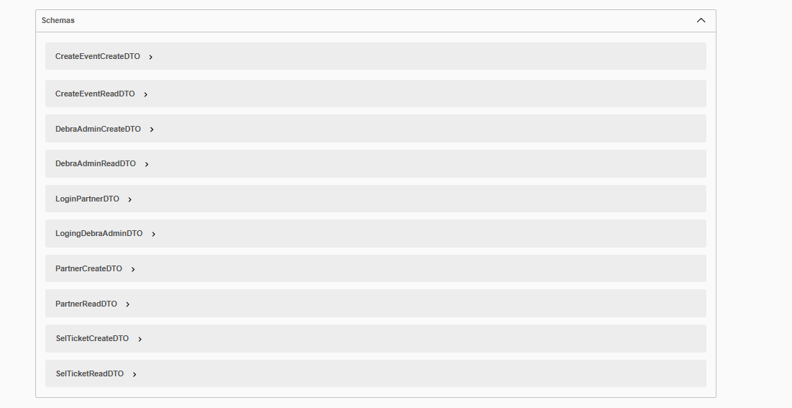Additionally, all schemas related to the DebraEventAPI will be shown in the Swagger UI as follows after the API project is finished.

Figure 32: Swagger UI

Therefore, it can be said that **DebraEventAPI** has been successfully built to function with all of the prerequisites for an event management system to be implemented successfully.

Constructing a useful and intuitive client application for the Debra event management system comes next, after the API's implementation.

**Partner behavior:-**

* 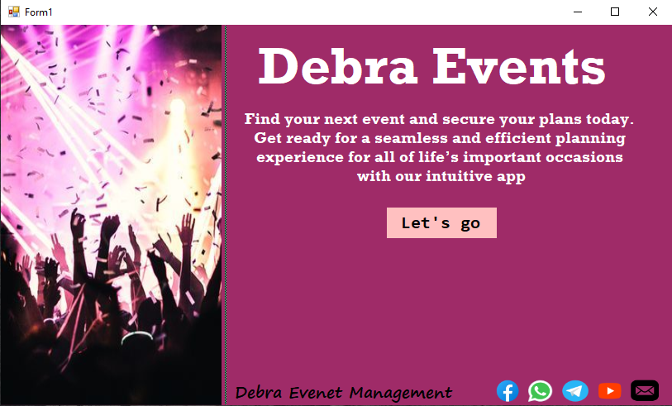When a user opens the Debra Event Web application, the screen that appears is the home screen. It will give the user a quick look at the company name, main logo and brief description in a simple and attractive manner as shown below. Clicking "Let’s go" at the bottom will take the user to the login screen.

Figure 33:APP Intro

* Following the start screen, users will seamlessly transition to the Dashboard screen of the application.
* If a new partner comes here, click on the registration button to the registration screen.
* If someone has registered before, they can either go to the login screen or log out.

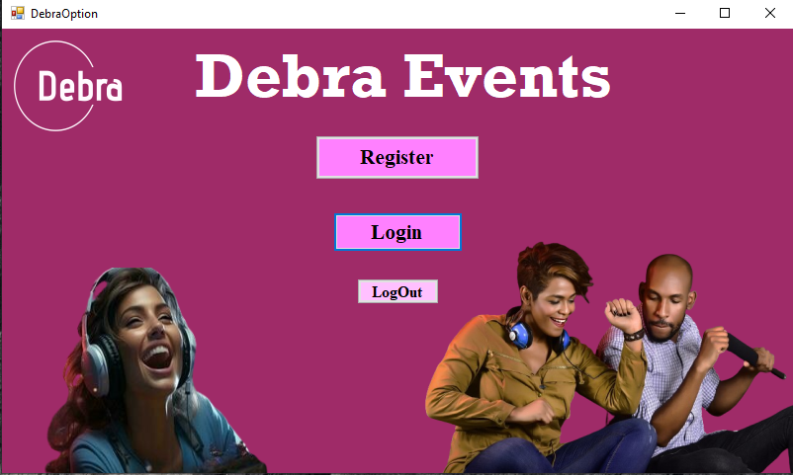

Figure 34: Debra Event Option

* When a new partner accesses the system, that user can registered in the system. The register option of the system is as follows.

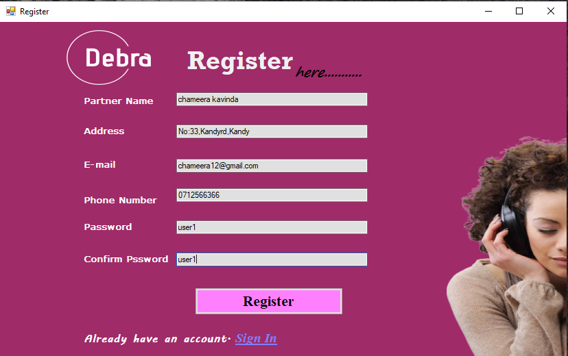

Figure 35:Partner Register Option

* After providing valid information as shown above, clicking the register button will register the new partner in the system.
* The registration procedure is validated using the following code, which is also used to effectively maintain registered users' connections throughout the system.

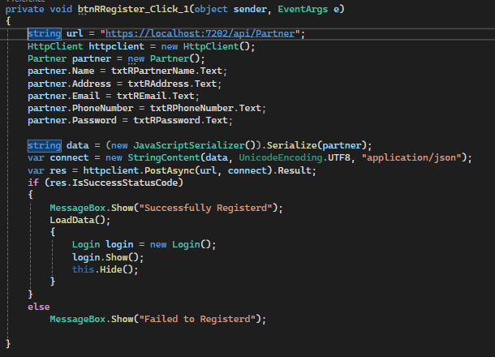

Figure 36: Partner Register button code

* After successfully registering, the user will be directed to the Login screen. They can access the system by entering the valid email address and password they provided during registration.

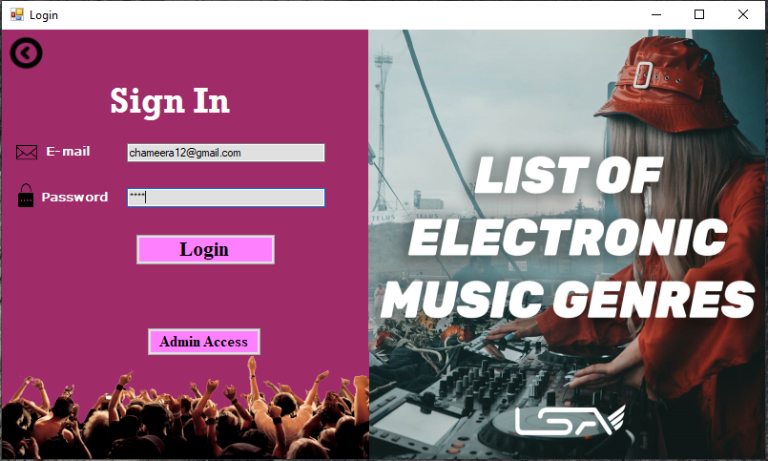

Figure 37: Partner Logging

* The login process is validated using the following code, which also helps keep registered users connected throughout the system.

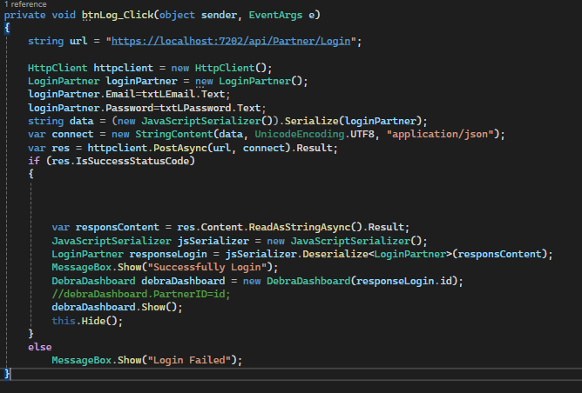

Figure 38:Partner Logging button code

* After providing Validate Email, Password, and accessing the system effectively, the screen shown to the user is as follows. According to the user's needs, the user will be able to access the Event screen or the Ticket screen. You can also access the login screen again by clicking profile.

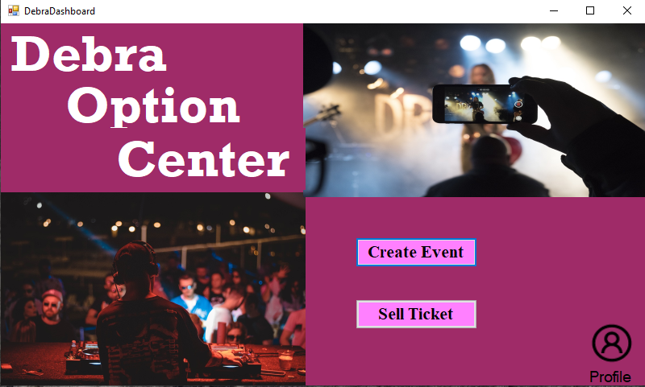

Figure 39: Debra Option Center

* A user who clicks **Event** on the above-mentioned screen will get the ability to successfully access the Event Option. When registering as a partner, a **Uniq PartnerID** will be received and only the Events included in it will be displayed here. Here you can add a new event, update event details and delete unnecessary events.

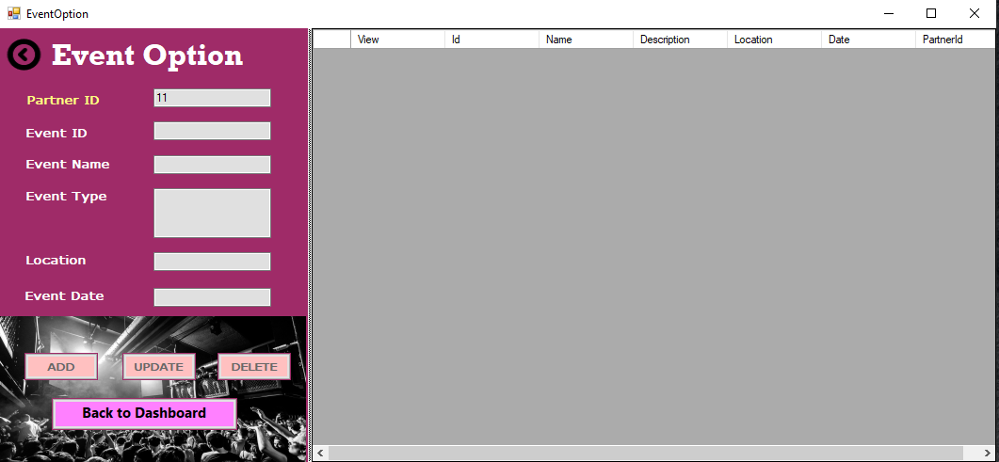**How to show the event options once a new partner logs in:**

Figure 40:New Partner display Event Option

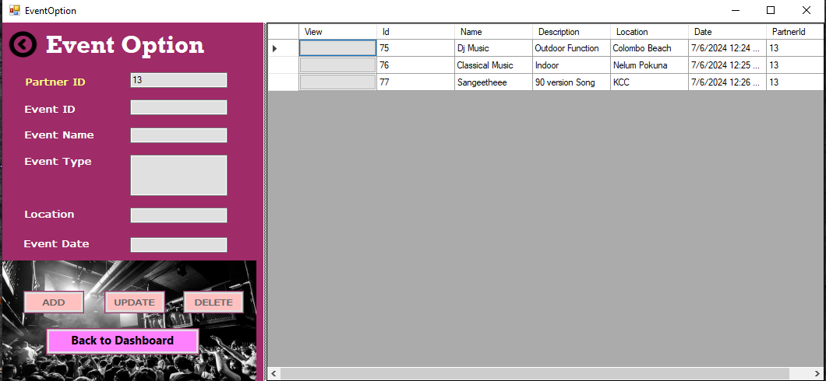**How to show event options after adding event:**

Figure 41: Event Option Show for partner

**The code related to adding new events is as follows.**

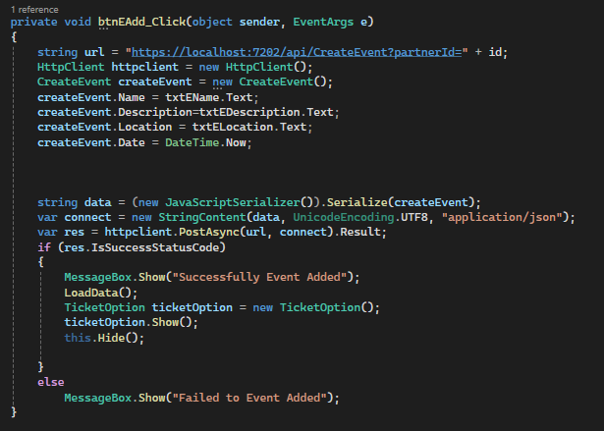

Figure 42: Event add code

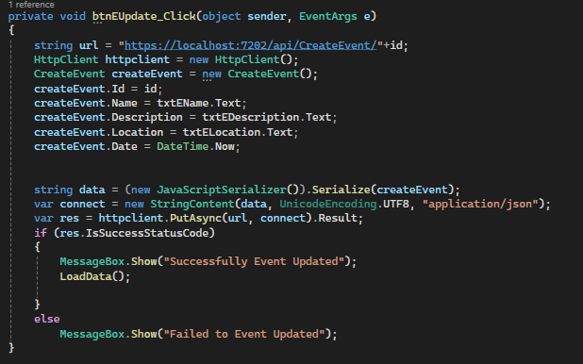**The code related to updating new events is as follows.**

Figure 43: Event Update button Code

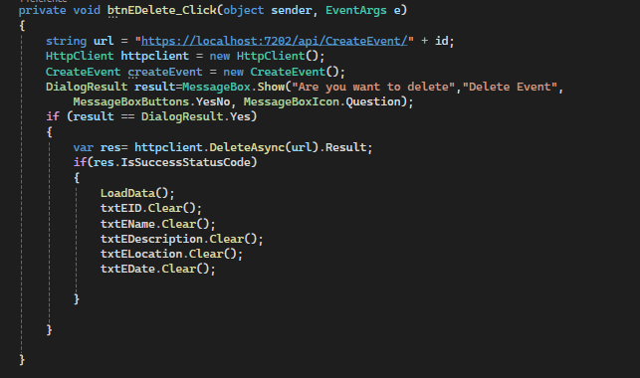**The code for deleting new events is as follows.**

Figure 44: Event Delete button Code

* 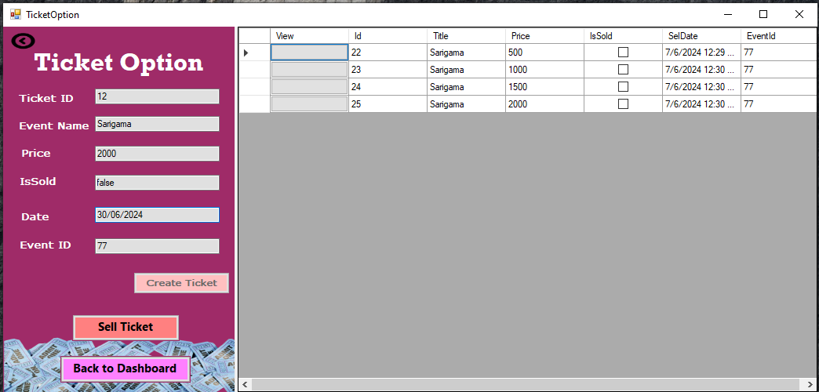After the event option, the screen shown to the partner is the ticket option. Here, the details of the existing tickets related to the **selected event** and the **details** of the currently sold tickets are displayed to the partner. You can sell tickets here as well as add a new ticket.

Figure 45:Ticket Option

**The code related to adding new Tickets is as follows**

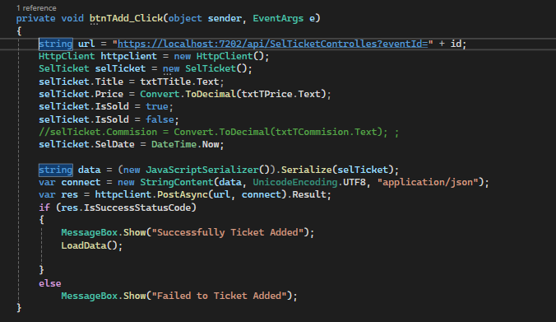

Figure 46: Ticket Add button Code

**Ticket Sell Option:-**

Figure 47:Sell Ticket

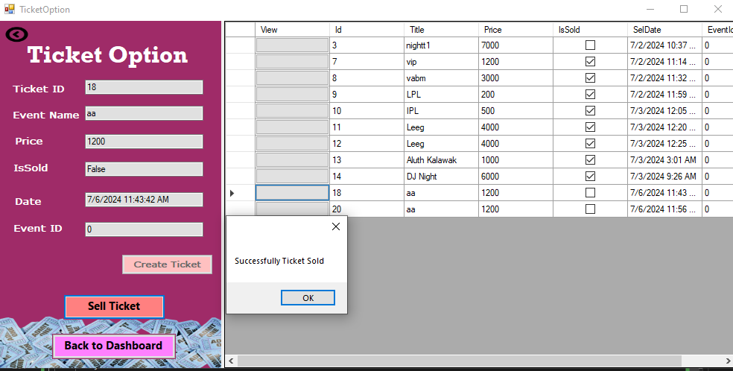

**The code related to Selling new Ticket is as follows**

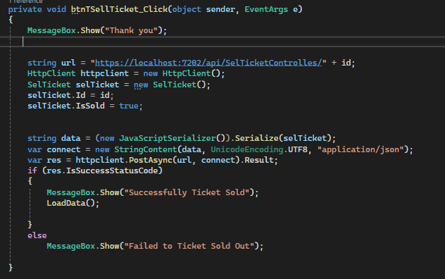

Figure 48: Sell Ticket button Code

**Admin behavior:-**

Registration is not applicable for Admin. Should any attempt be made to register an administrator, it disrupts the current operation, causing a malfunction (even if Users are logged in as Admin). To mitigate this issue, specific admin credentials have been predetermined, including an admin username and password.

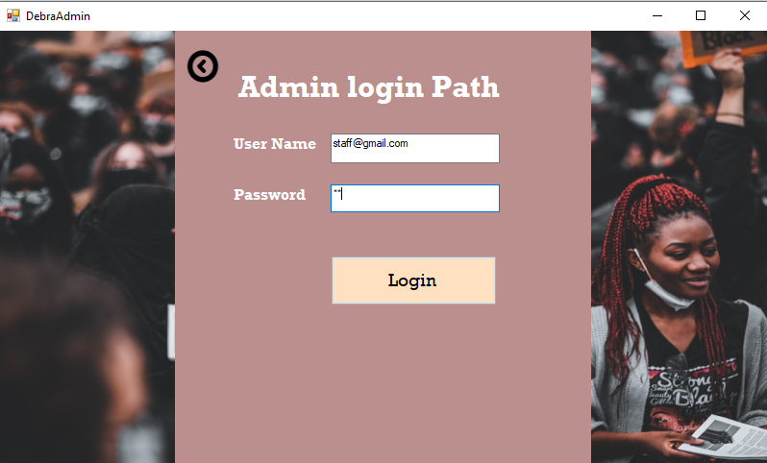

Figure 49: Admin Logging path

* After providing a registered Email and Password, the system can be successfully accessed through Admin login.
* The login process is validated using the following code, which also helps keep registered admins connected throughout the system.

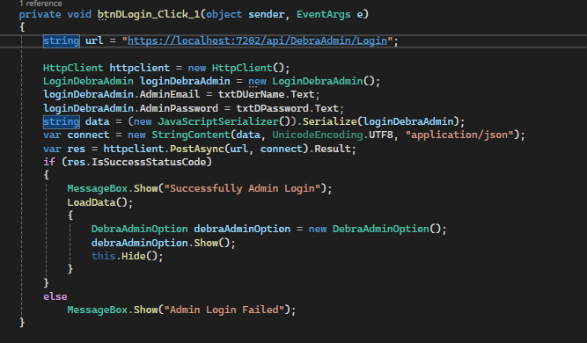

Figure 50: Admin Log button code

* 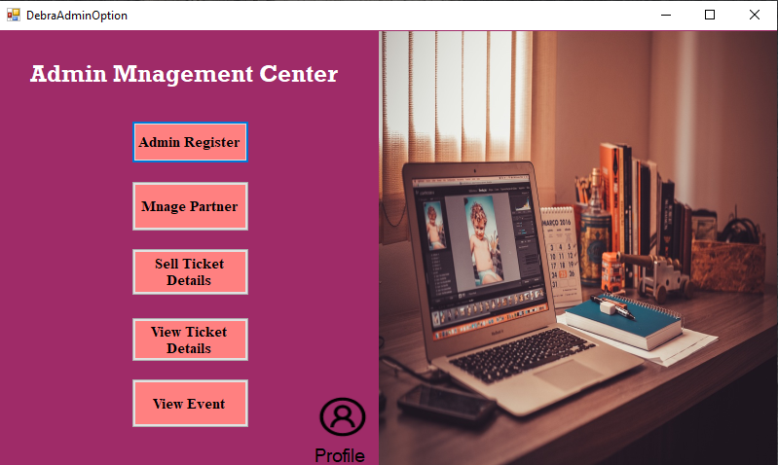Here, adding **a new Admin to the system**, **managing Admin details**, **managing Partner details**, **Viewing Commissions** received by the organization through tickets, **Viewing ticket details** and **managing** them. It is possible to perform processes such as **viewing event details** and **managing** them.

Figure 51: Admin Management Center

**View Admin details and Manage Admin Details:**

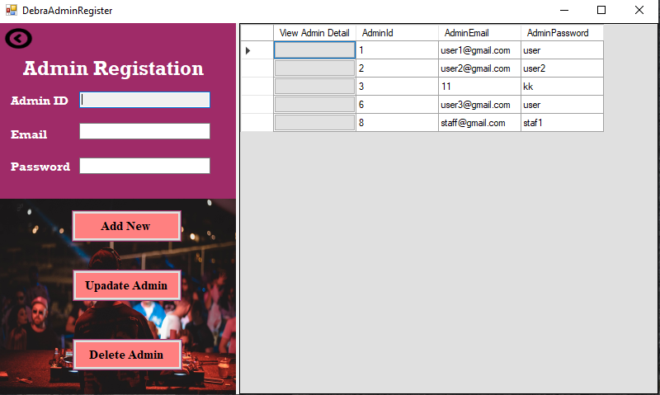Here, you can add a new administrator, update their details, or delete unnecessary information about administrators.**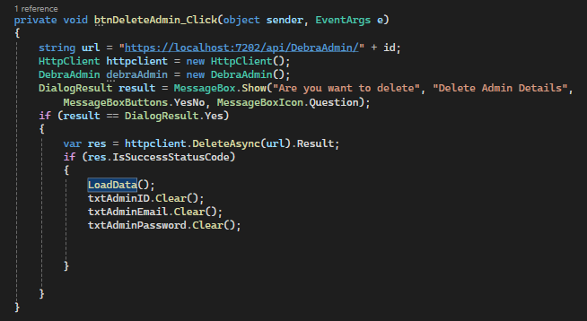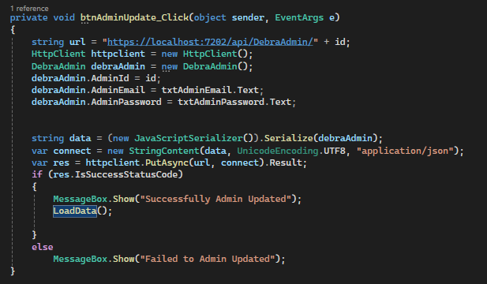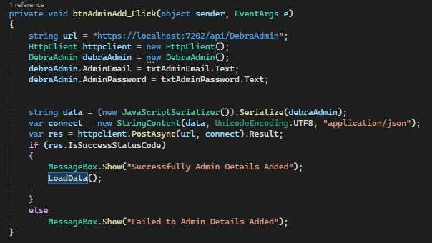The code related to adding new Admin is as follows**

Figure 52: New Admin Registration

Figure 53: Admin Delete Admin details button code

Figure 54: Admin Update Details button code

**The code related to Deleting new Admin is as follows**

Figure 55: Admin Add New Admin button code

**The code related to Updating new Admin is as follows**

**View Partner details and Manage Partner Details:**

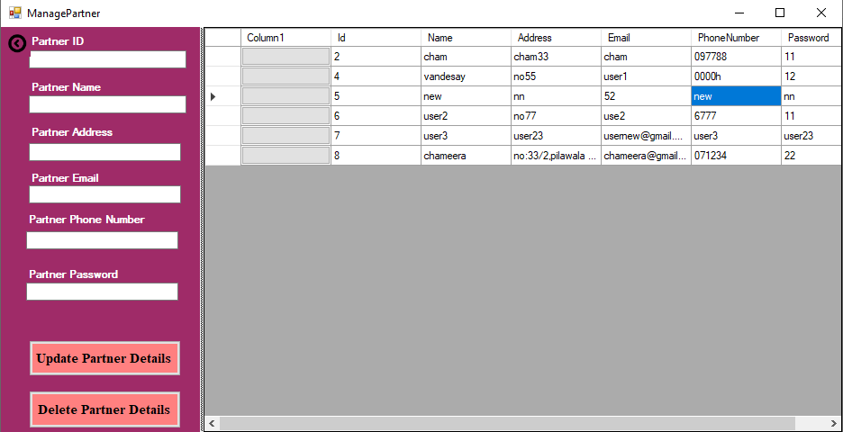Here, you can Update Partner details, or delete unnecessary information about Partners.

Figure 56: Manage Partner Option

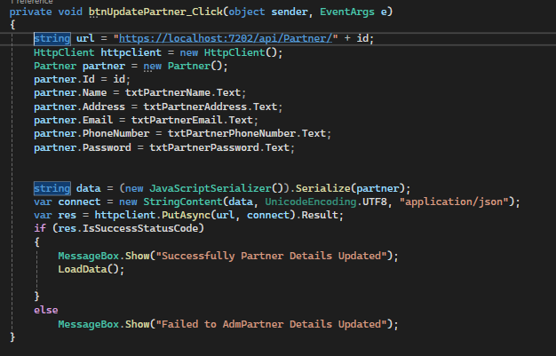

**The code related to Deleting Partner details is as follows**

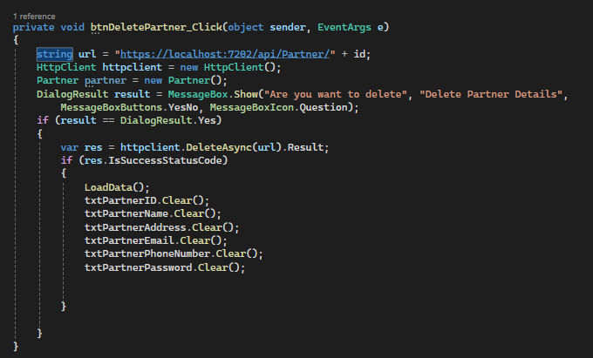

**The code related to Updating Partner details is as follows**

**View commission details:**

* 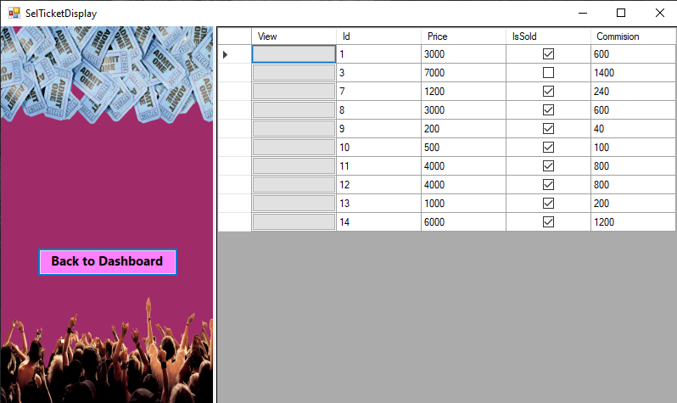Here is the information on the commissions Debra Event Management earns from ticket sales**.**

Figure 57: View Commission

**Admin Ticket Option:**

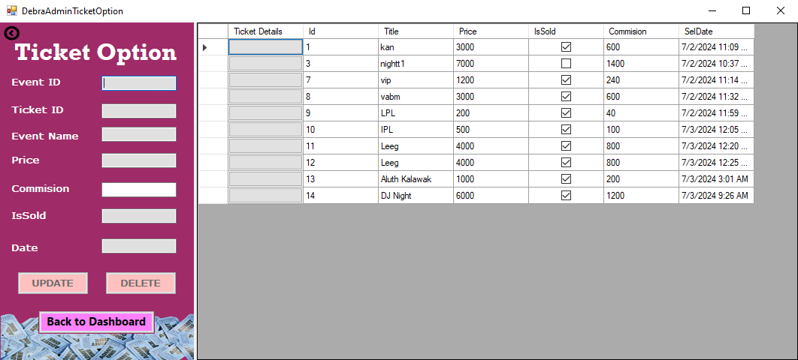Here an administrator can update ticket information, delete unnecessary ticket information.

Figure 58: Admin Ticket option

**Admin Event Option:**

* 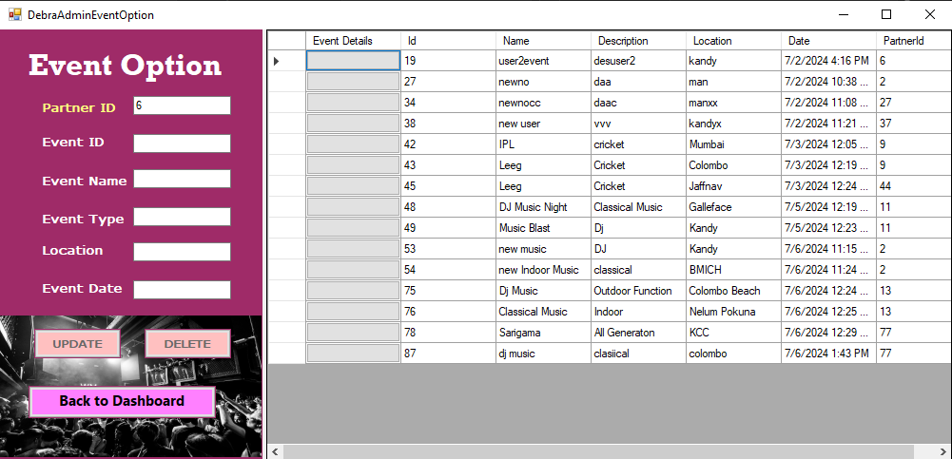Here an administrator can update ticket information, delete unnecessary ticket information.

Figure 59: Admin Event option

* As a result, it can be said that the Debra Event Management System Client application has been successfully developed in a fashion that satisfies all requirements for an effective Event Management System implementation.
* It's clear that the Debra Event API and the Client application for Debra Event Corporation were created in a Service-Oriented Computing (SOC) environment. This approach allowed for the development of reusable, scalable, and productive features, ensuring better scalability and advanced capabilities.

# **Task 03:-**

## **Testing of the API**

* 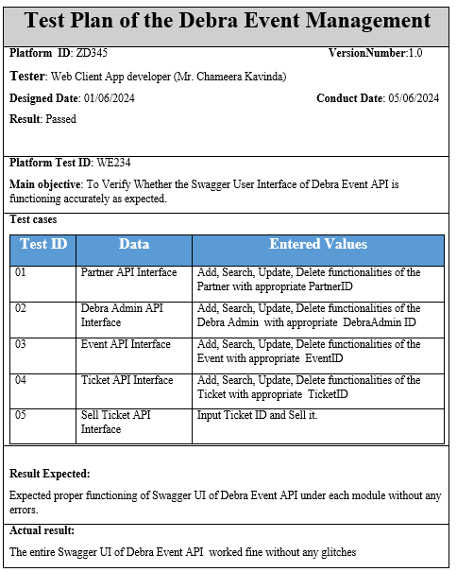A test plan can be created to test the developed DebraEventAPI as follows:

As a result, the following example test cases were utilized to evaluate the DebraEventAPI.

Figure 60: Partner API Interface

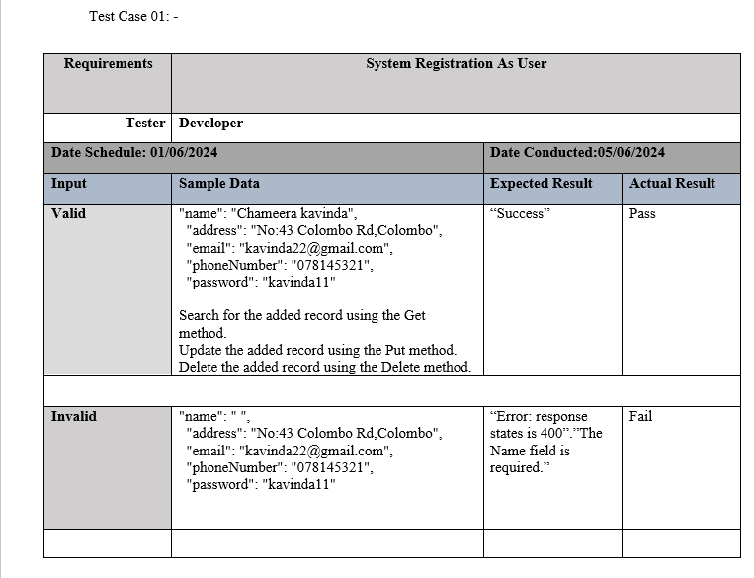

**Partner API Interface**

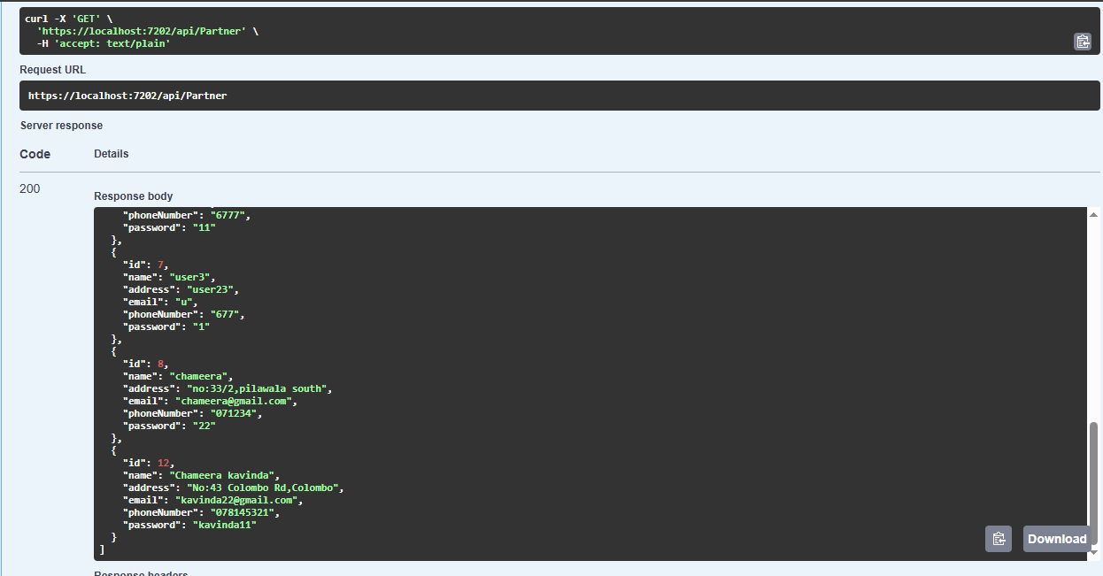**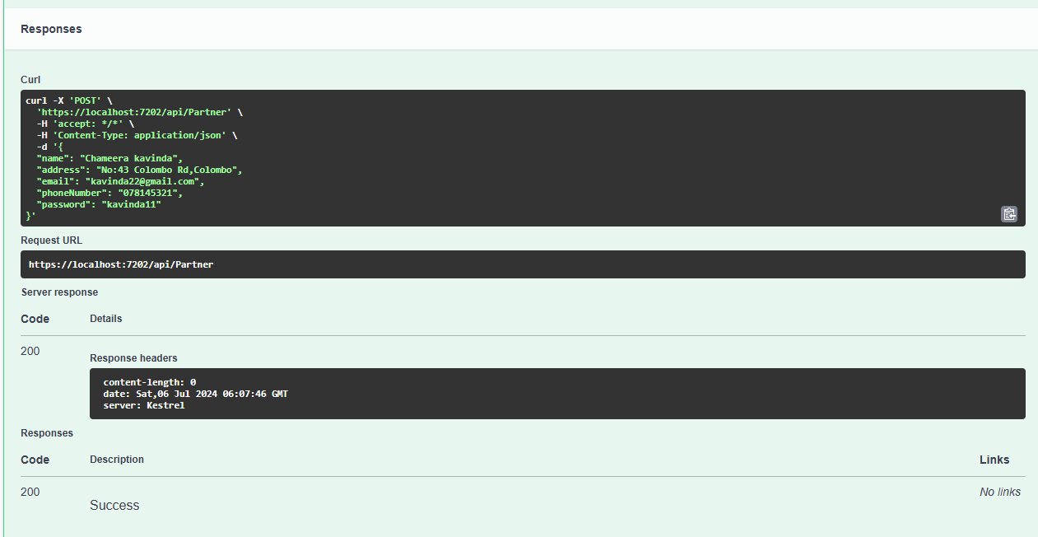Positive Test Case:**

Figure 61:Partner API GET

Figure 62:Partner API POST

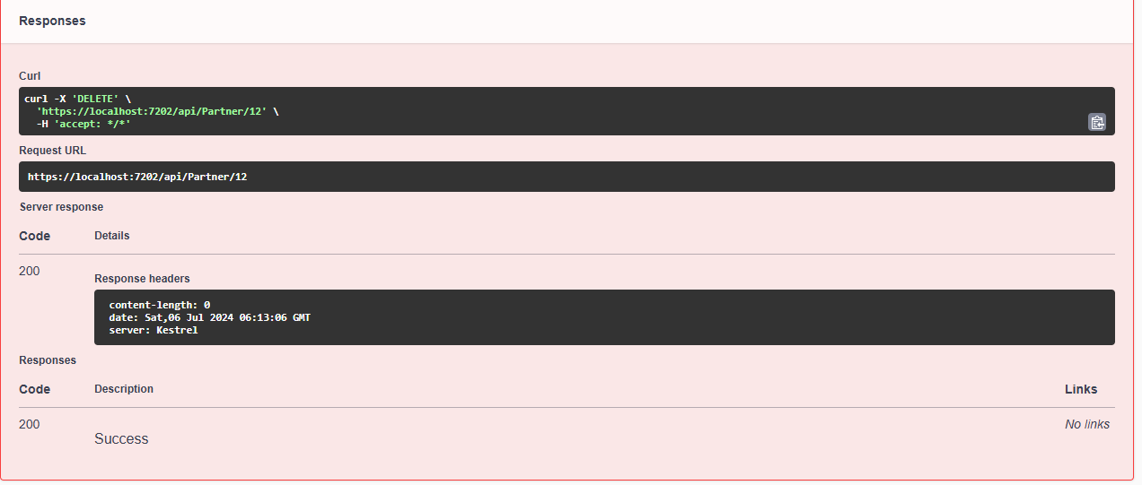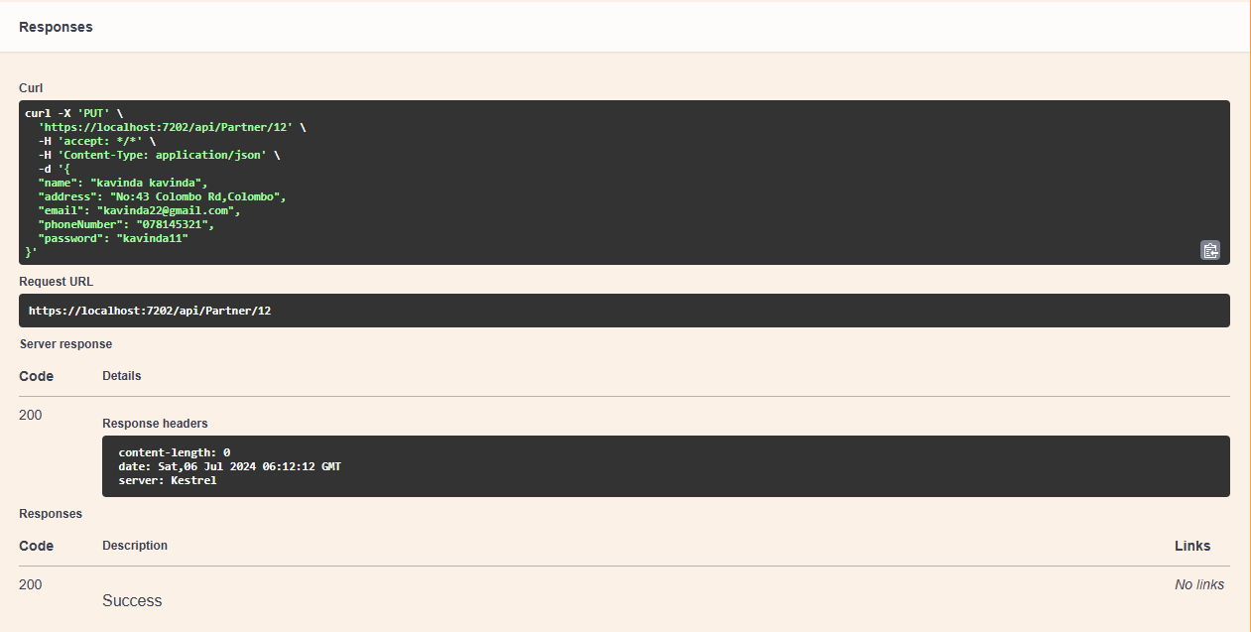

Figure 63:Partner API DELETE

Figure 64:Partner API PUT

**Negative Test Case:**

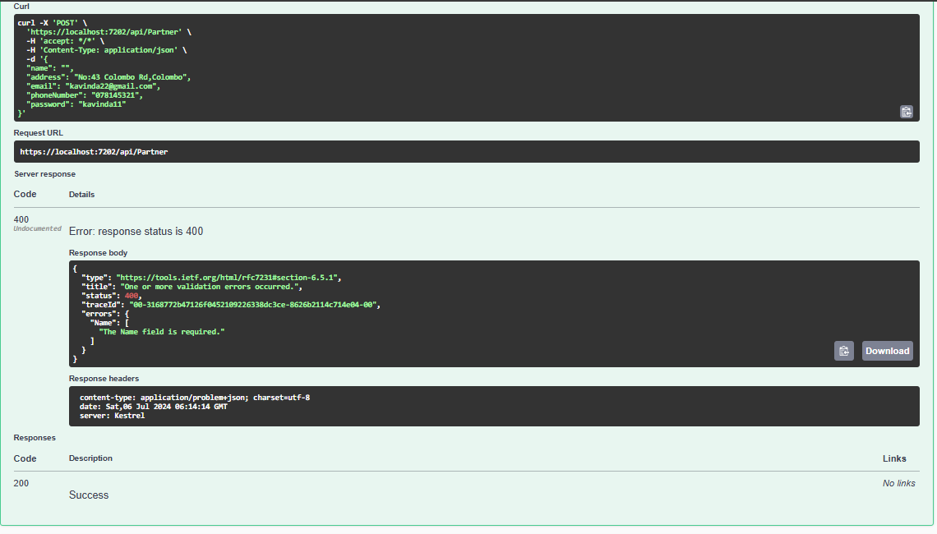

Figure 65:Partner API POST Negative

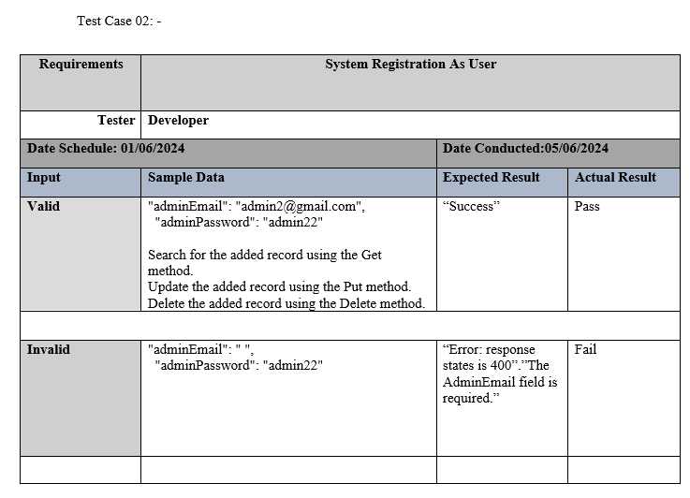

**Debra Admin API Interface**

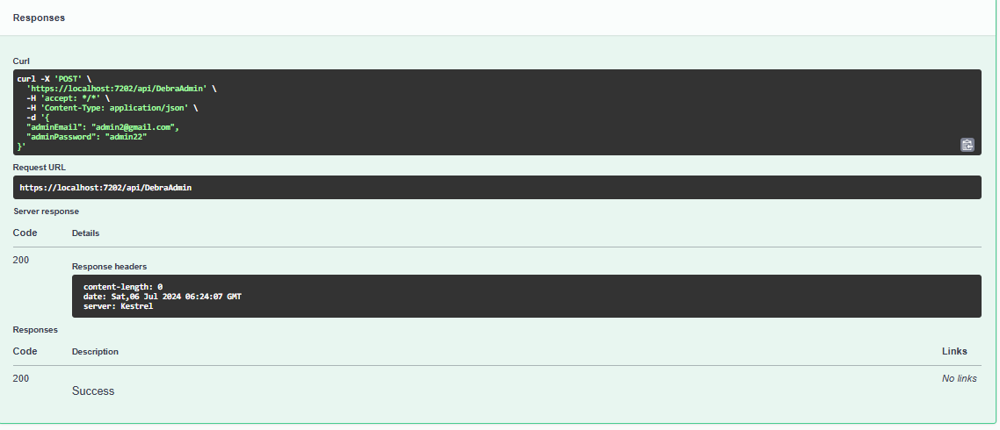**Positive Test Case:**

Figure 66:Admin API Interface

Figure 67:Admin API POST

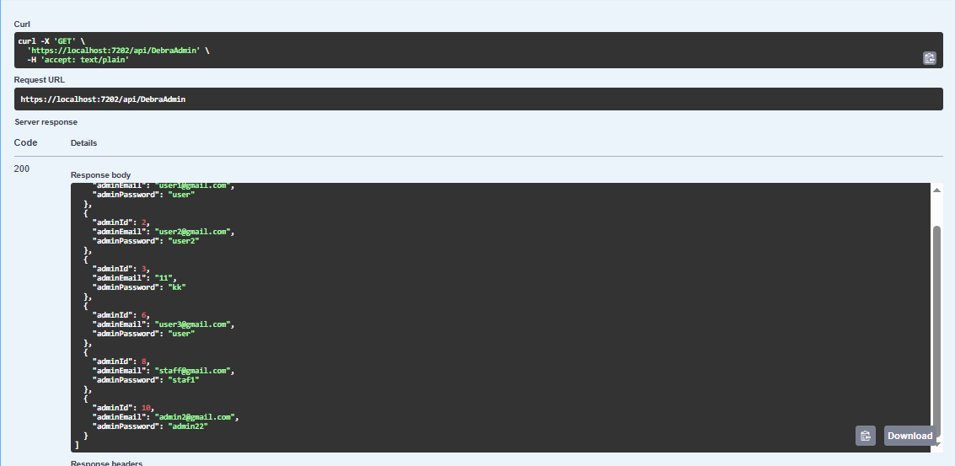

Figure 68:Admin API GET

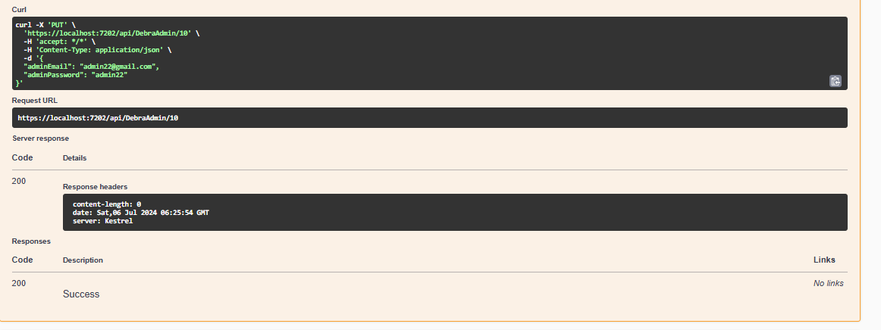

Figure 69:Admin API PUT

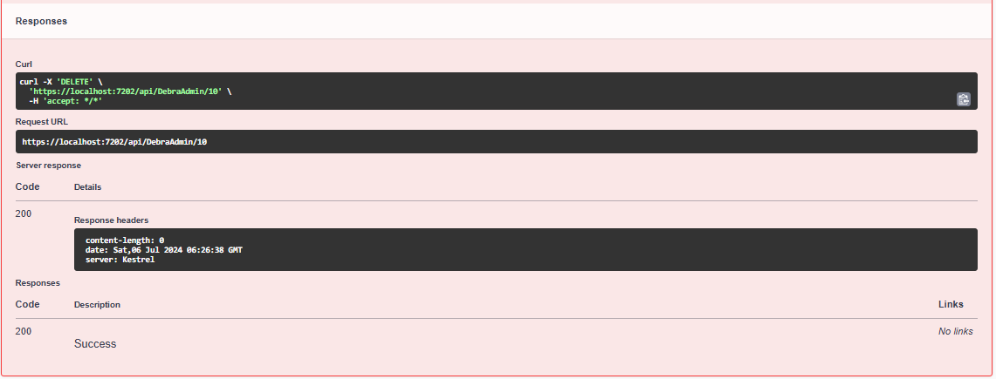

Figure 70:Admin API DELETE

**Negative Test Case:**

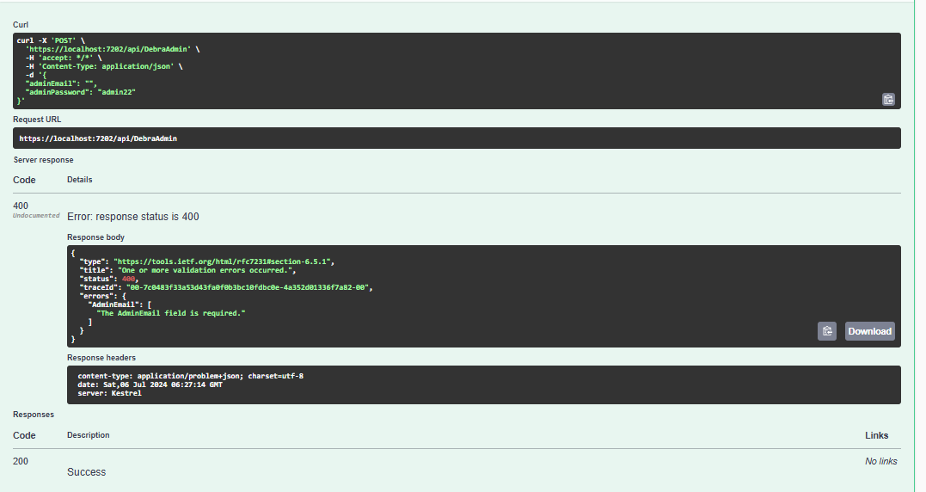

Figure 71: Admin API POST Negative

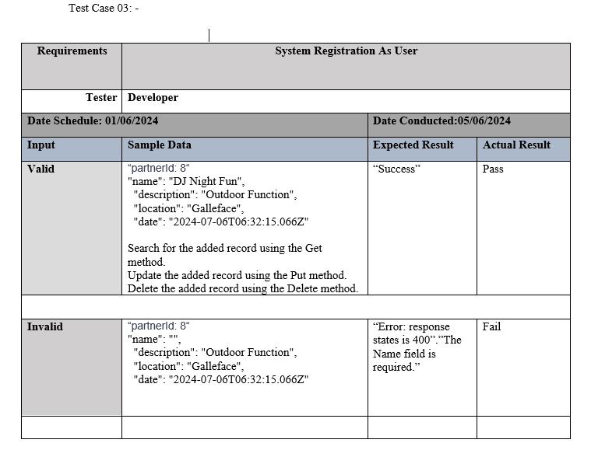

**Event API Interface**

Figure 72: Event API Interface

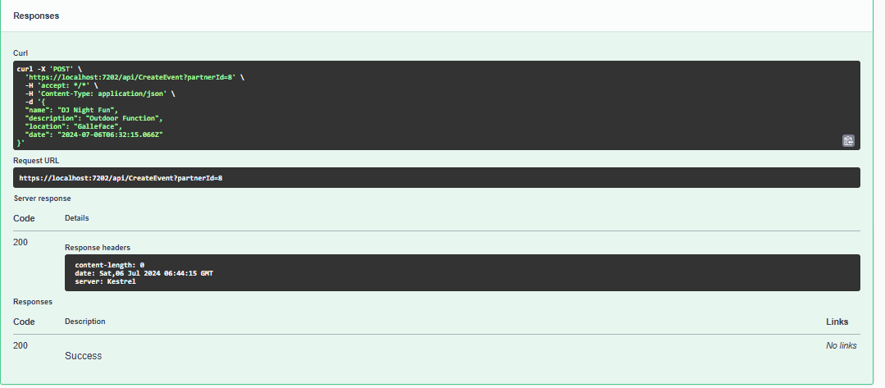**Positive Test Case:**

Figure 73: Event API POST

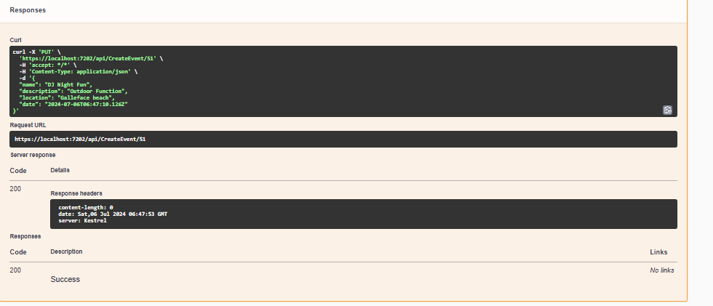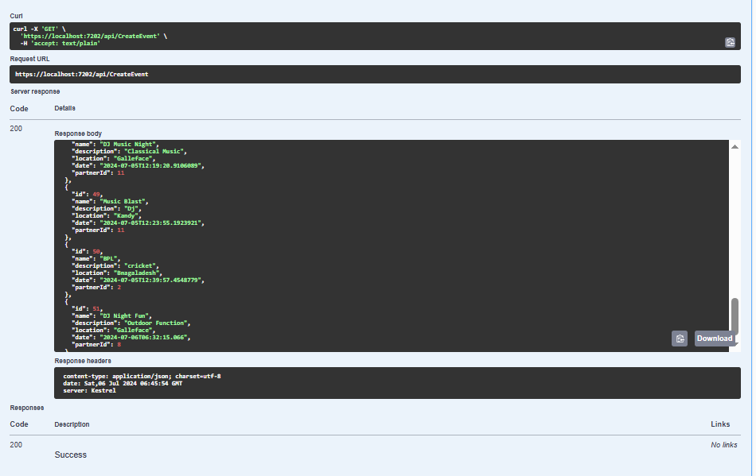

Figure 74:Event API PUT

Figure 75: Event API Get

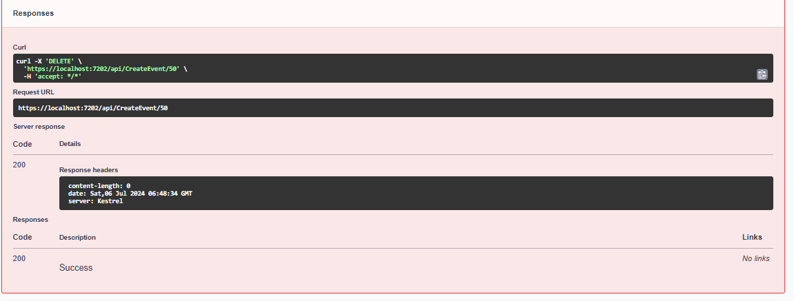

Figure 76: Event API DELETE

**Negative Test Case:**

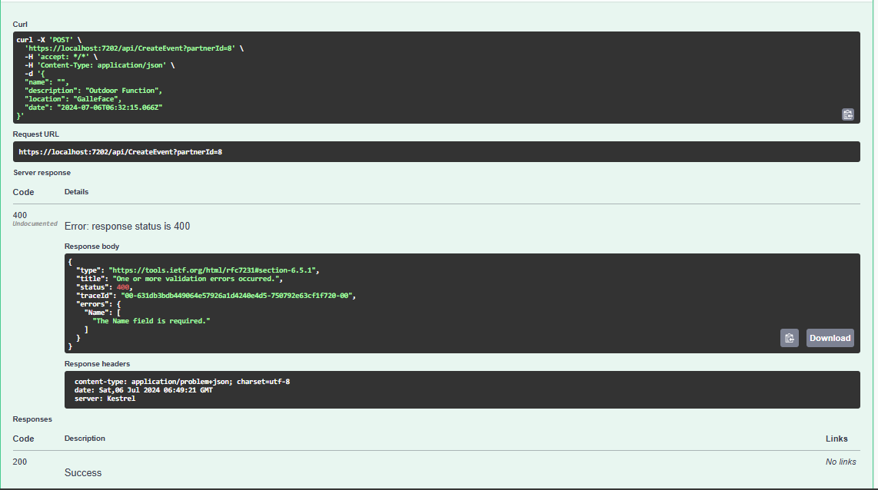

Figure 77: Event API POST Negative

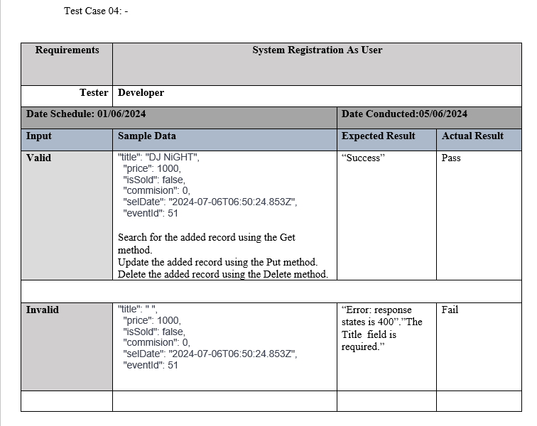

**Ticket API Interface**

Figure 78: Ticket API Interface

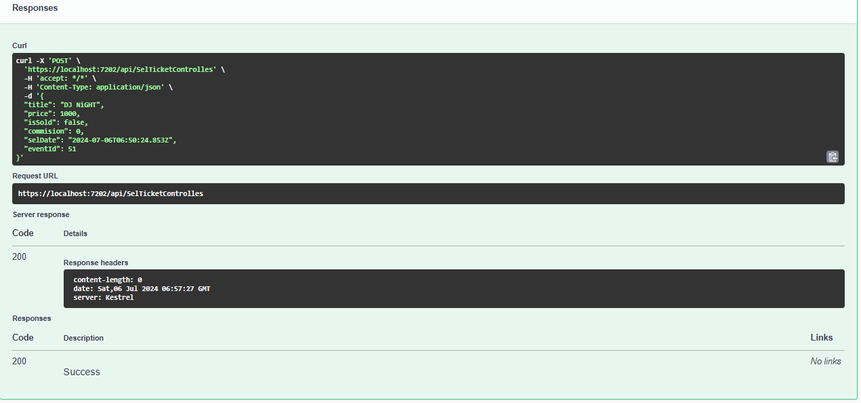**Positive Test Case:**

Figure 79: Ticket API POST

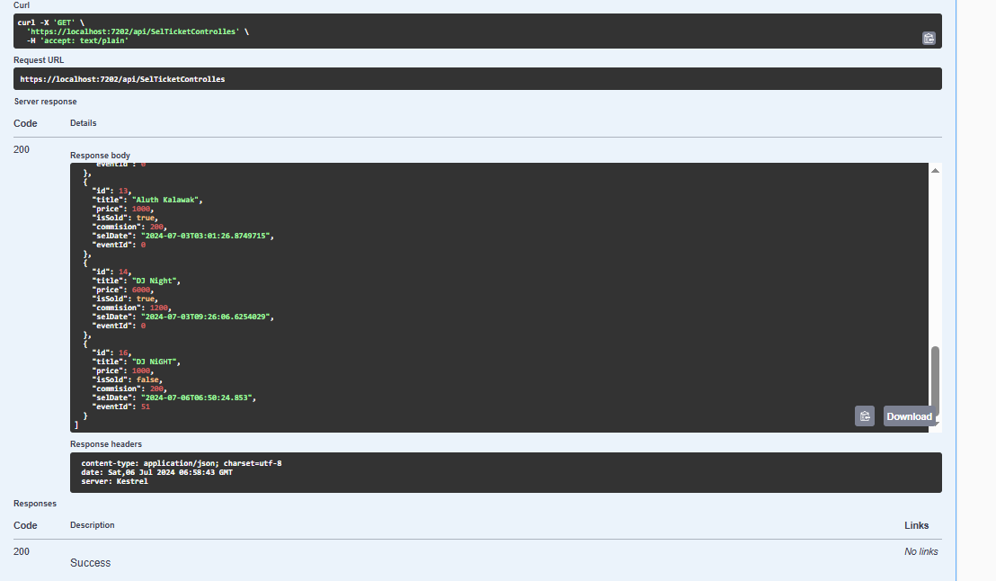

Figure 80: Ticket API GET

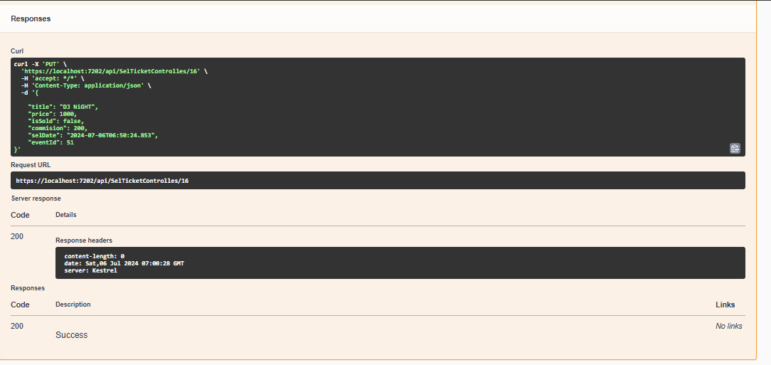

Figure 81: Ticket API PUT

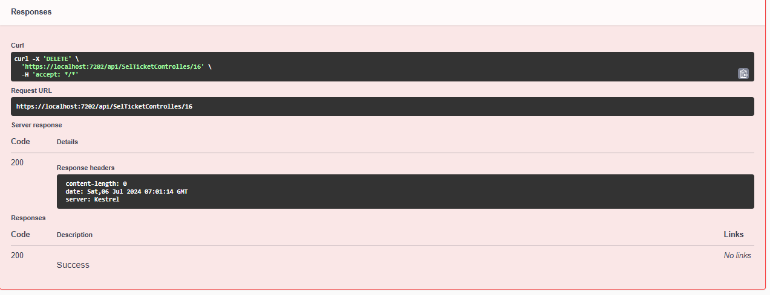

Figure 82: Ticket API DELETE

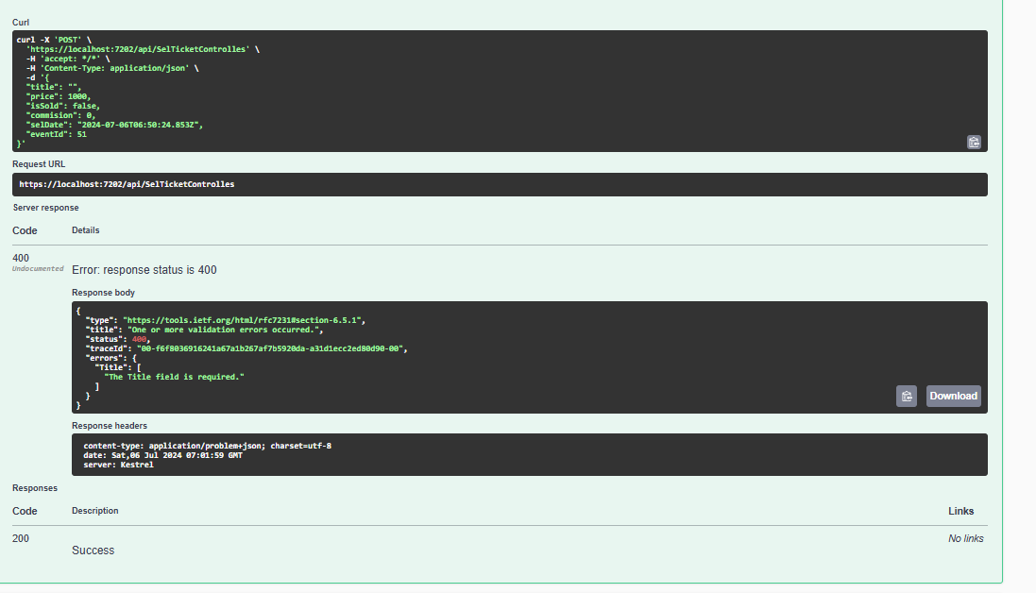**Negative Test Case:**

Figure 83: Ticket API POST Negative

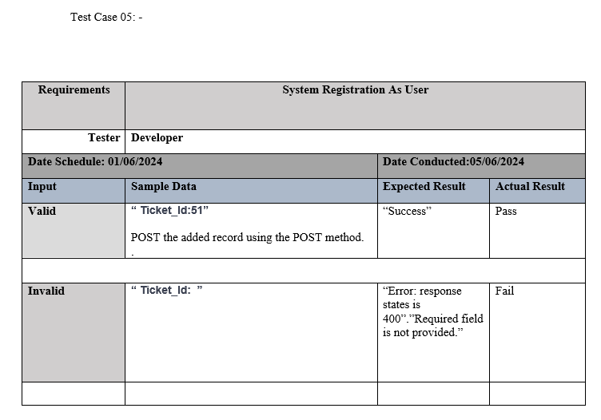

**Sell Ticket API Interface**

Figure 84: Sell Ticket API Interface

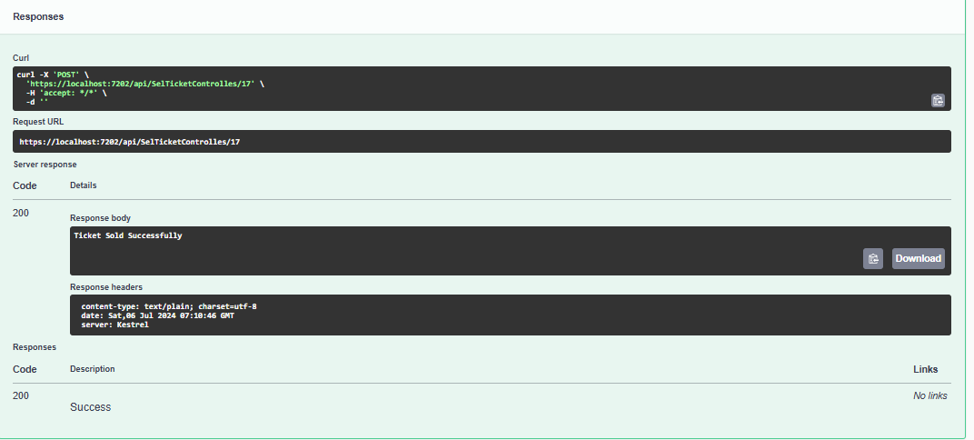**Positive Test Case:**

Figure 85: Sell Ticket API Post

**Negative Test Case:**

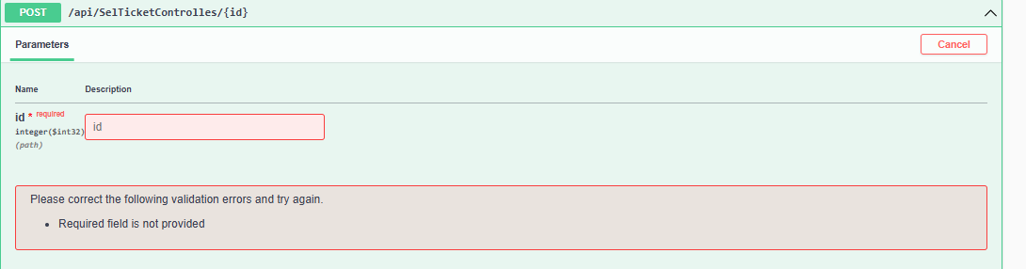

Figure 86: Sell Ticket API Negative

* Therefore, based on the pertinent tests carried out for each module, it is evident that the DebraEventAPI as a whole operated effectively and efficiently.

## **Testing the Client Application:**

Figure 87: Testing the Client Application:

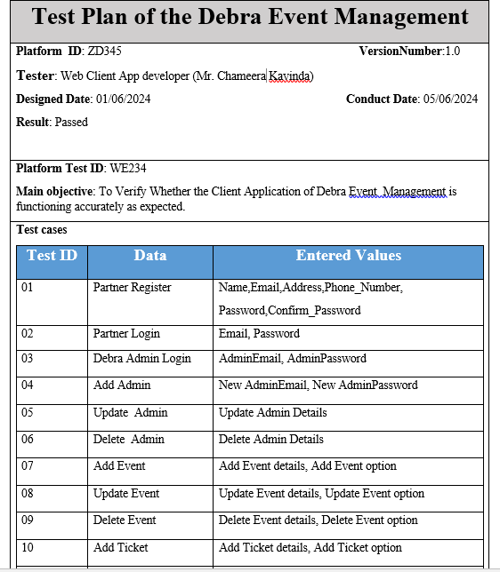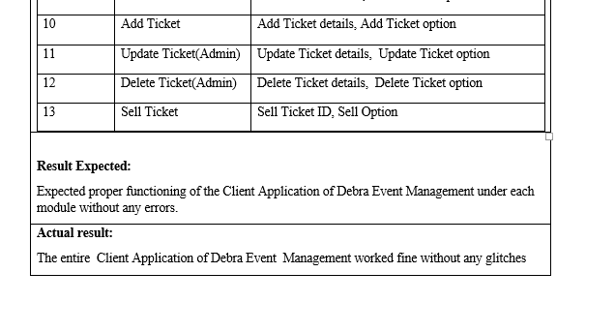

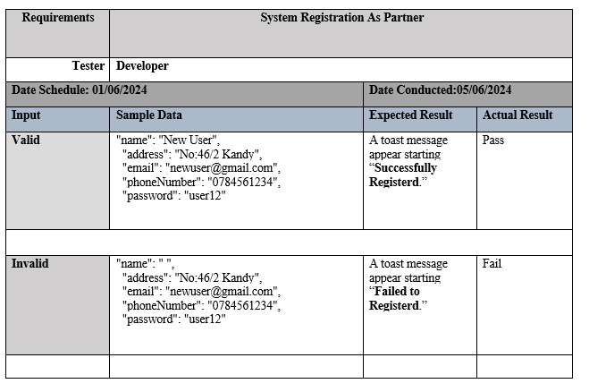**Test Case 1:-**

Figure 88: Sytem Registation as a partner

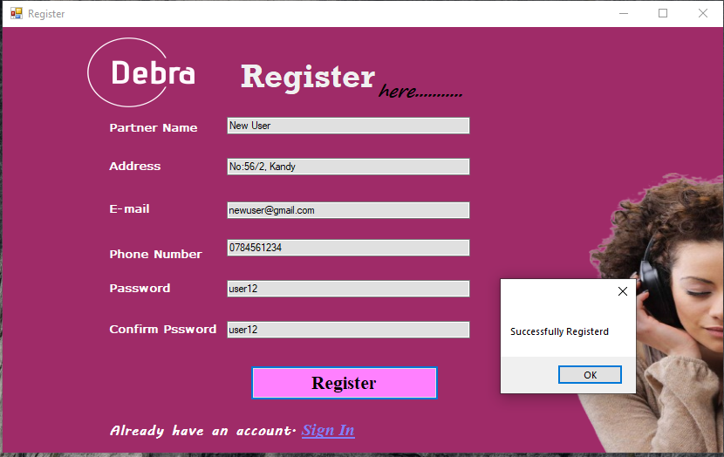**Positive Test Case:**

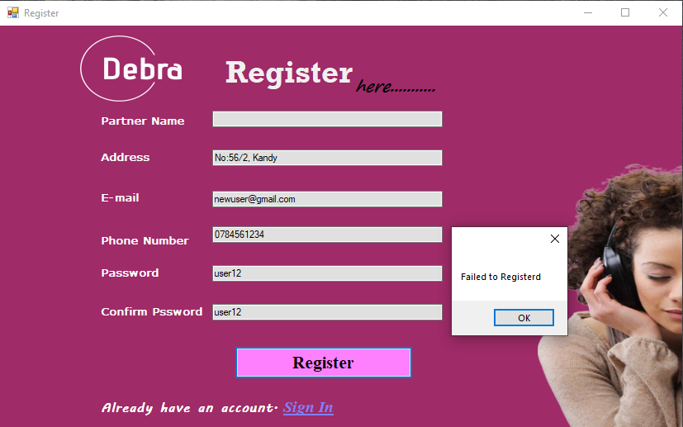**Negative Test Case:**

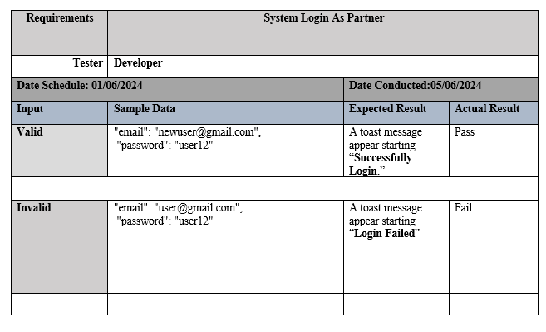**Test Case 2:-**

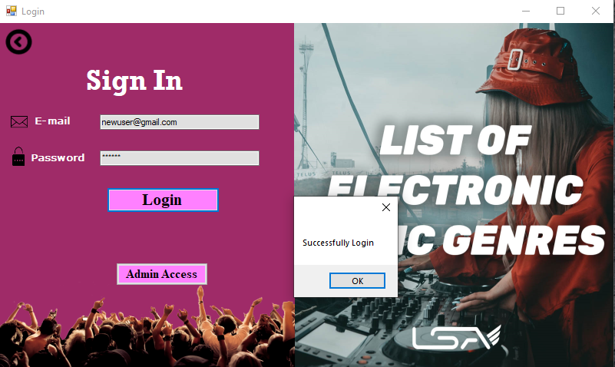**Positive Test Case:**

Figure 89: System logging as a Partner

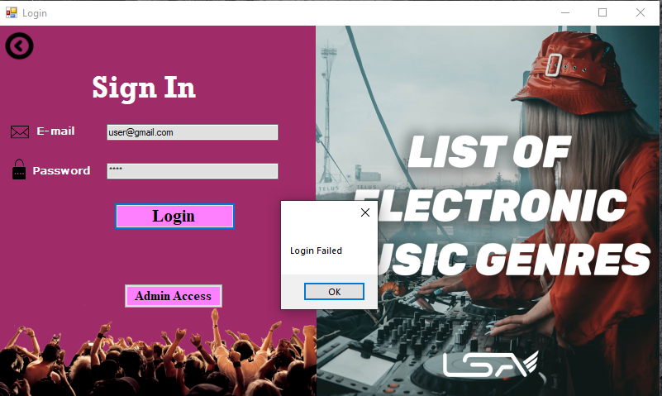**Negative Test Case:**

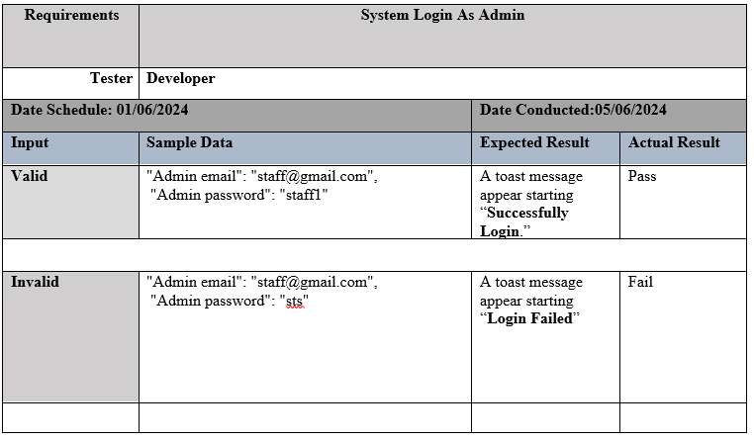Test Case 3:-

Figure 90: System Logging as a Admin

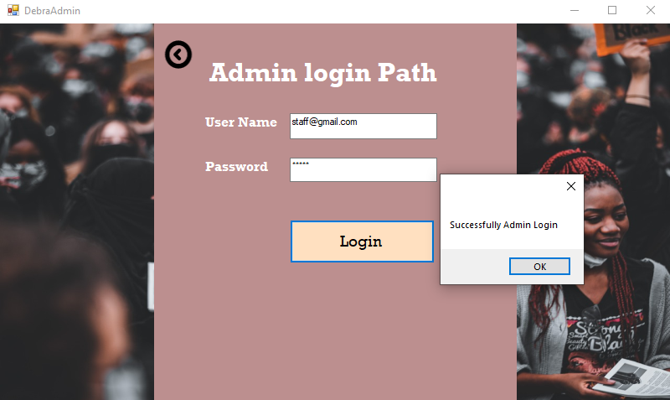**Positive Test Case:**

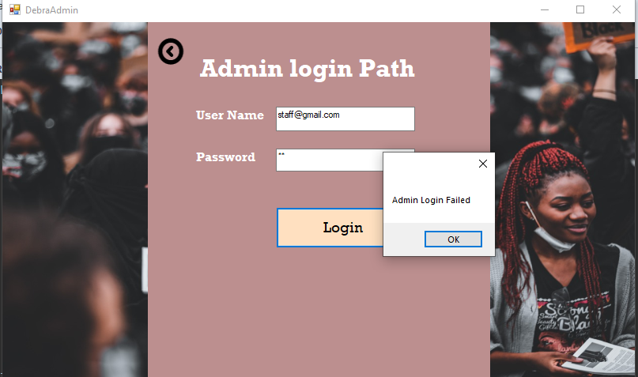**Negative Test Case:**

Test Case 4:-

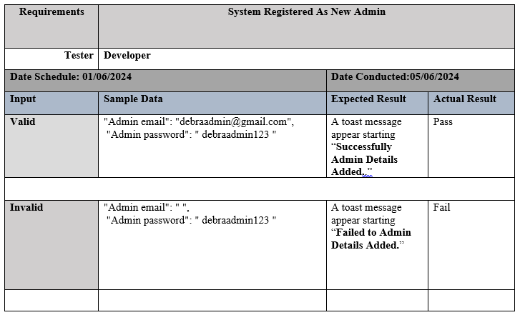

Figure 91: System registered as a New Admin

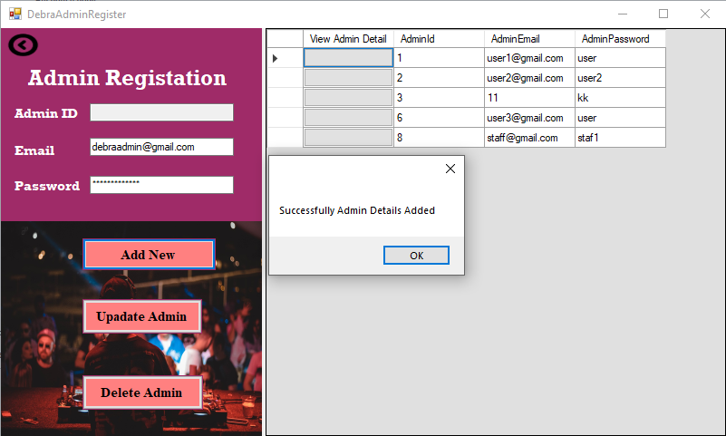**Positive Test Case:**

**Negative Test Case:**

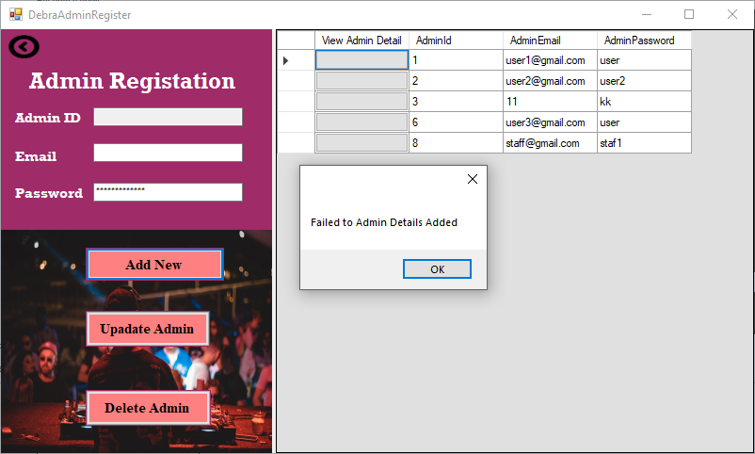

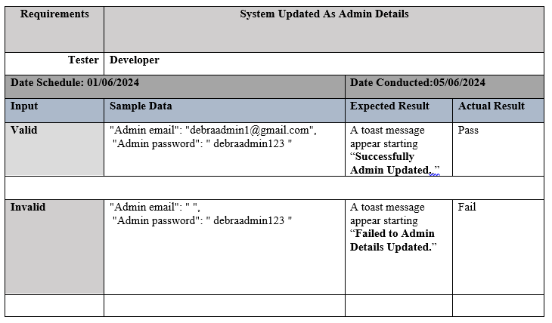Test Case 5:-

Figure 92:System Updated as a Admin Details

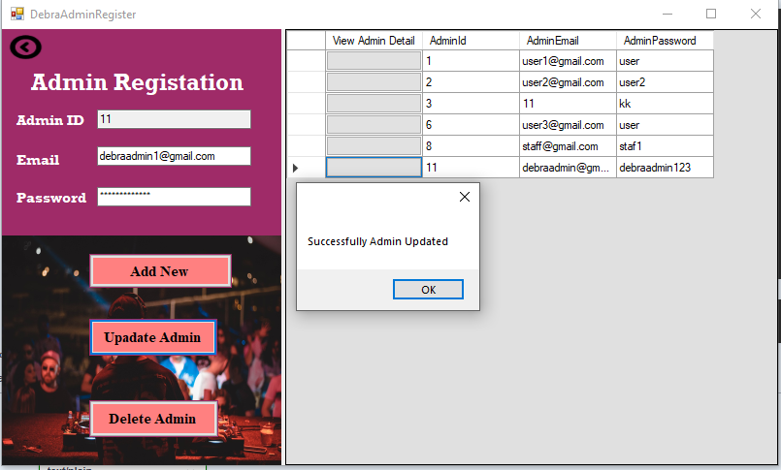**Positive Test Case:**

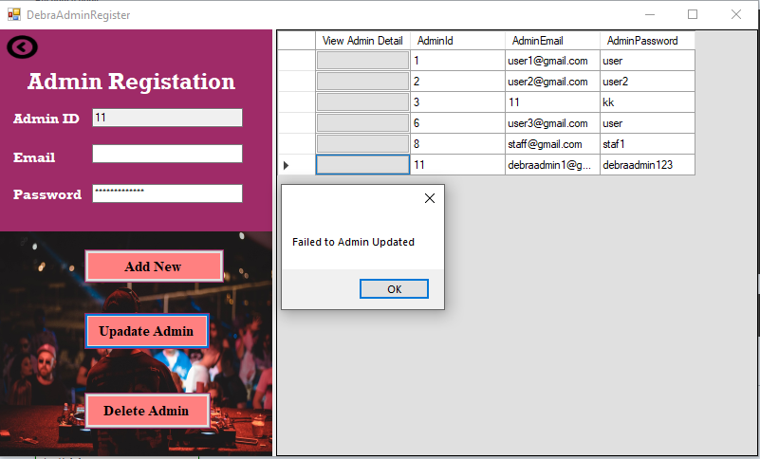**Negative Test Case:**

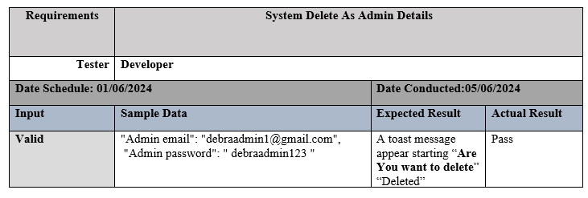Test Case 6:-

Figure 93: System Delete as a Admin details

**Positive Test Case:**

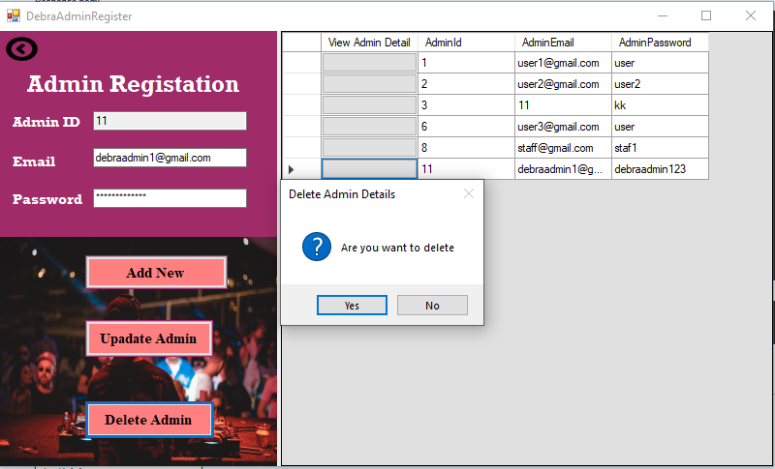

Figure 94: Positive Test Case

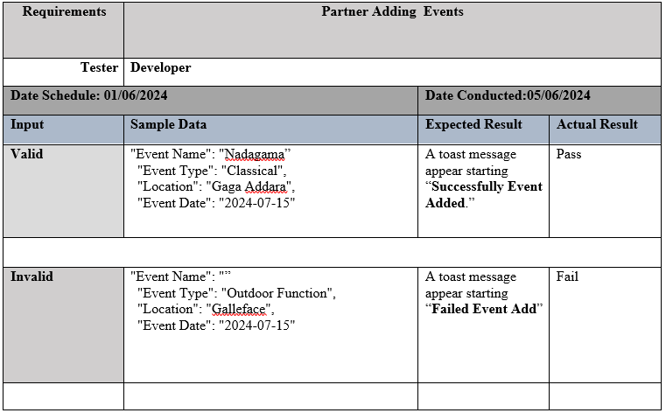Test Case 7:-

Figure 95: Partner Adding Events

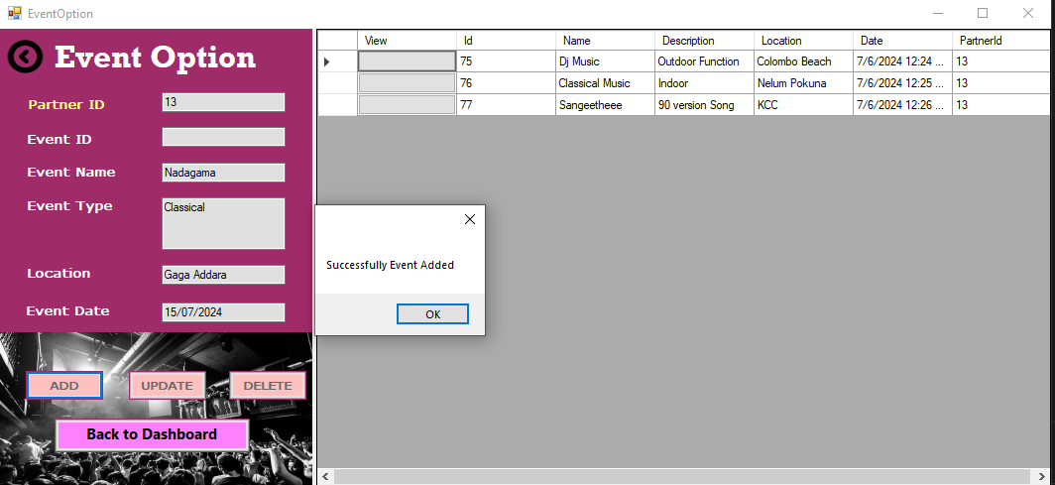**Positive Test Case:**

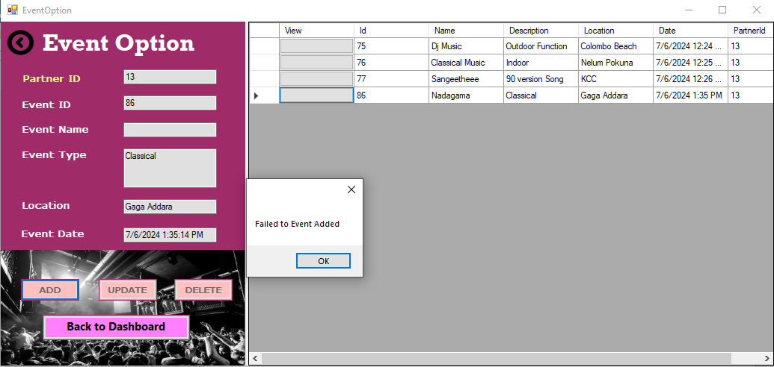**Negative Test Case:**

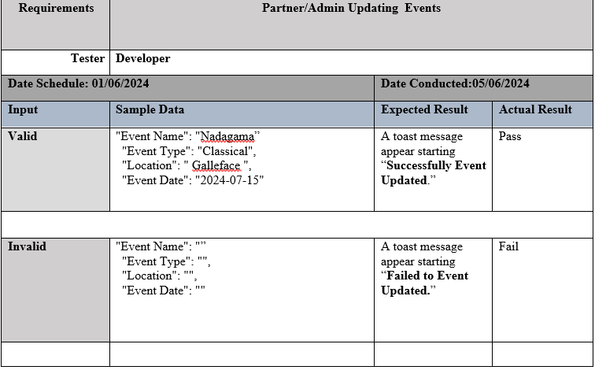Test Case 8:-

Figure 96: Partner/Admin Updating Events

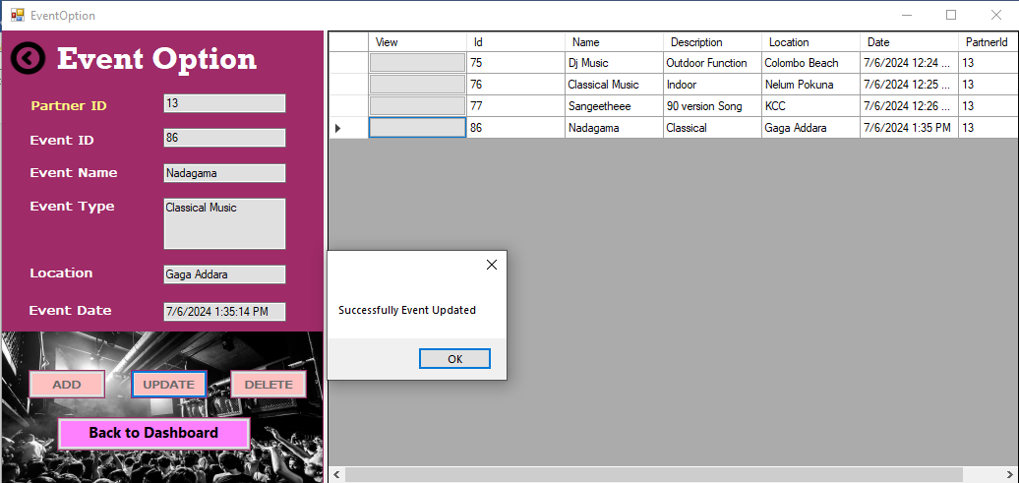**Positive Test Case:**

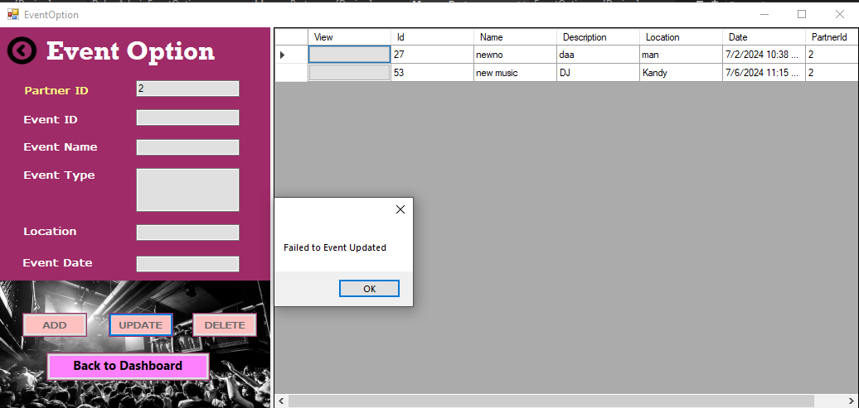**Negative Test Case:**

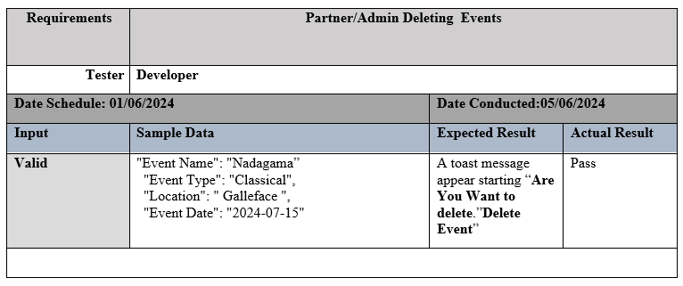Test Case 9:-

Figure 97: Partner/Admin Deleting Events

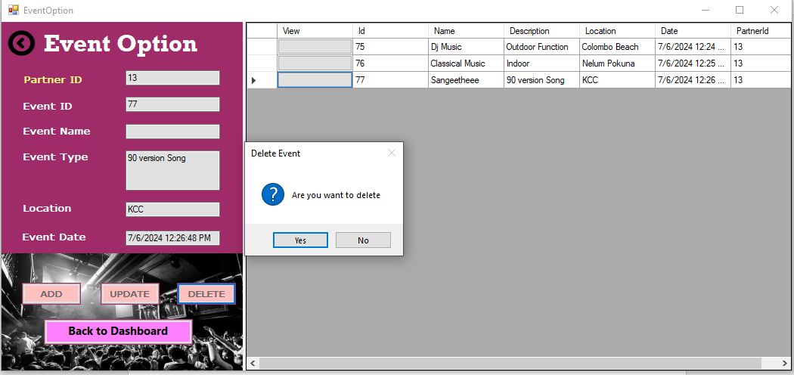**Positive Test Case:**

Figure 98: Positive Test Case

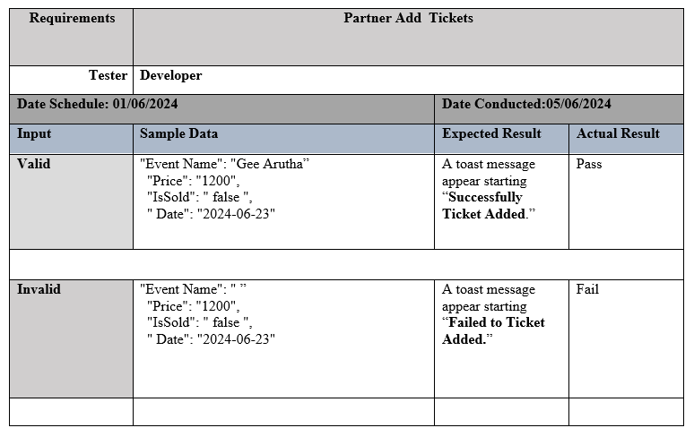Test Case 10:-

Figure 99: Partner Add Tickets

**Positive Test Case:**

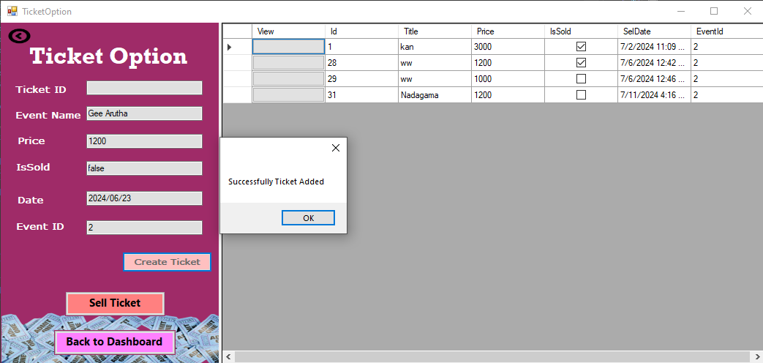

12

**Negative Test Case:**

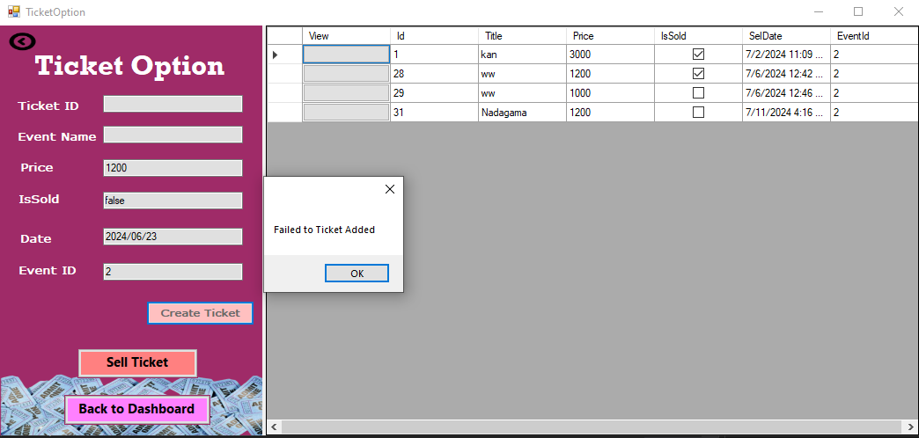

12

Test Case 11:-

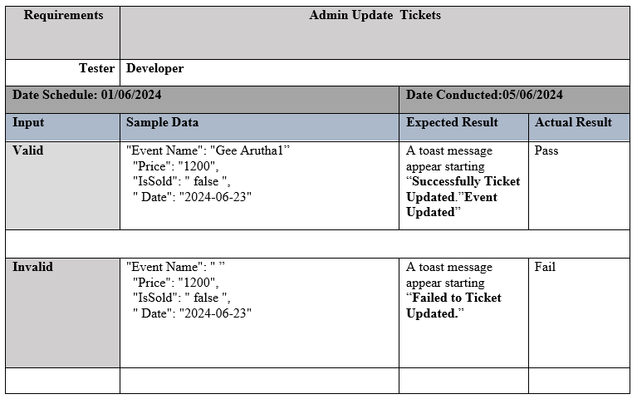

Figure 100: Admin Update Tickets

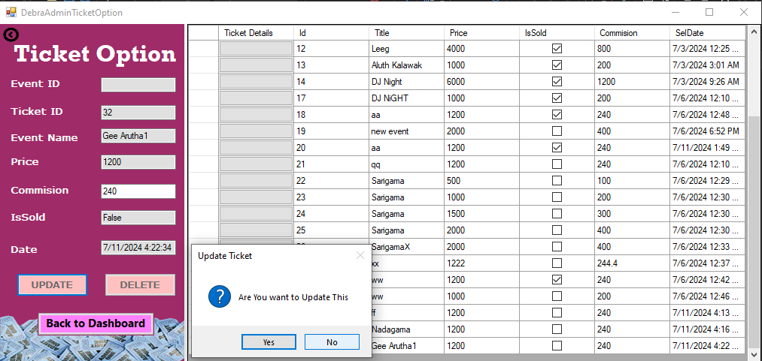**Positive Test Case:**

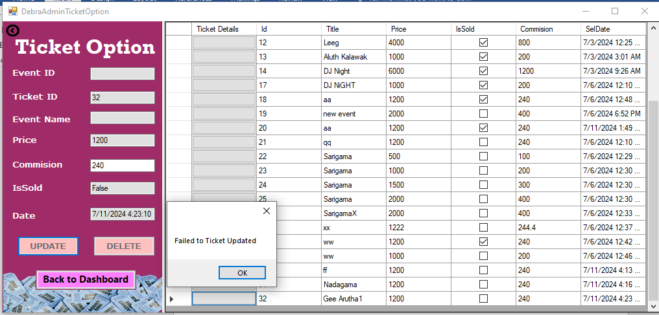**Negative Test Case:**

Test Case 12:-

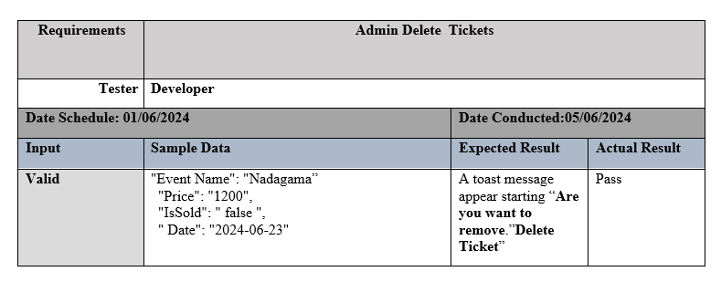

Figure 101: Admin Delete Tickets

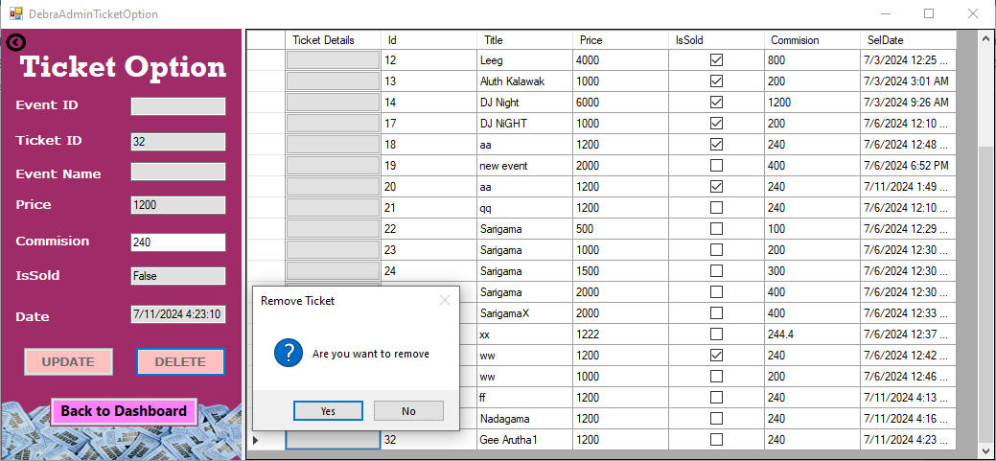**Positive Test Case:**

Figure 102: Positive Test Case

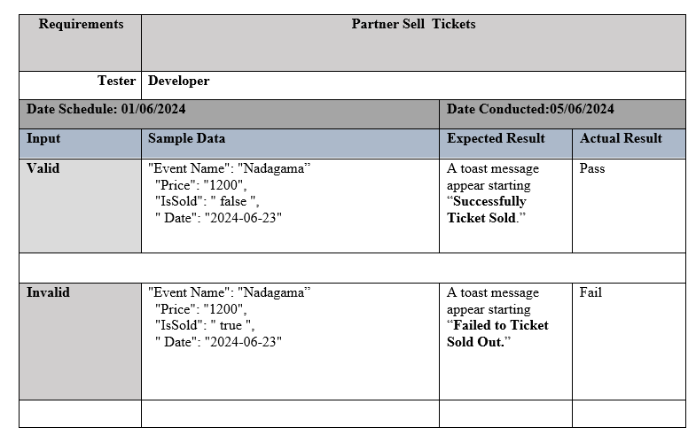Test Case 13:-

Figure 103: Partner Sell Tickets

**Positive Test Case:**



**Negative Test Case:**

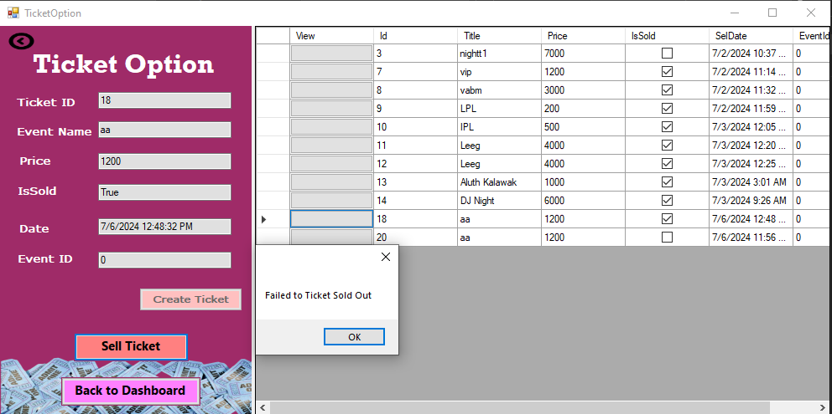

## **Test Result:-**

* As expected, the Debra Event Management System worked well with the DebraEventAPI and Client Application, providing all required outputs in response to developers' inputs.
* As a result of building all connections to the Debra database in a more stable and efficient manner, all essential methods in the API and windows within the Client App read data correctly and execute successfully.
* The developed API and Client App work as expected system implemented in a SOC based environment with highly scalable and reusable features.
* Debra Event Management System has high security because only authorized users are allowed to enter and use the system.
* So it can be clearly analyzed that the developed Debra Event Management System is an efficient and effective SOC based system that addresses all the essential functions of partners and Debra Admin Panel very effectively and successfully.

# **Task 04**

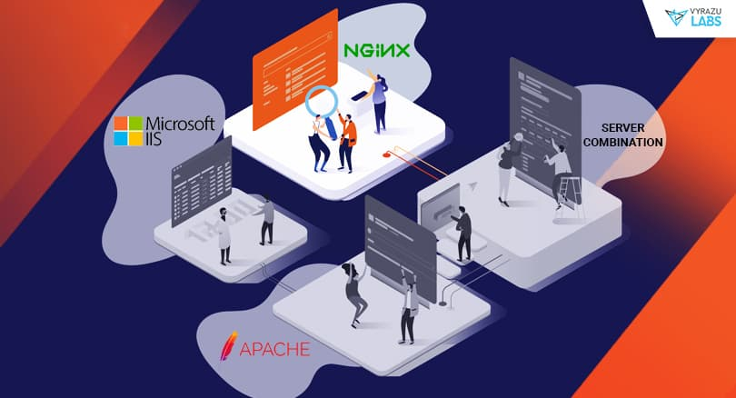The following deployment methods can be taken into consideration in order to implement the Service-Oriented Computing (SOC) based solution for Debra: Kubernetes orchestration, Docker containers, and traditional server deployment. Here is a critical comparison of these choices along with an explanation of the best approach.

## **Traditional Server Deployment**

**Advantages:-**

* **Simplicity**: Smaller applications can be easily set up and managed.
* **Allocation** **of** **Resources**: Direct authority over the server's resources.
* **Customization**: High level of server environment customization (ramtechpcs, n.d.).

**Disadvantages:-**

* **Scalability**: Scaling calls for manual intervention. Applications that anticipate rapid growth should not use this.
* **Maintenance**: It can take time to do regular maintenance, security patches, and upgrades.
* **Use** **of** **Resources**: Utilization of resources that could be inefficient because scaling up requires adding whole servers.

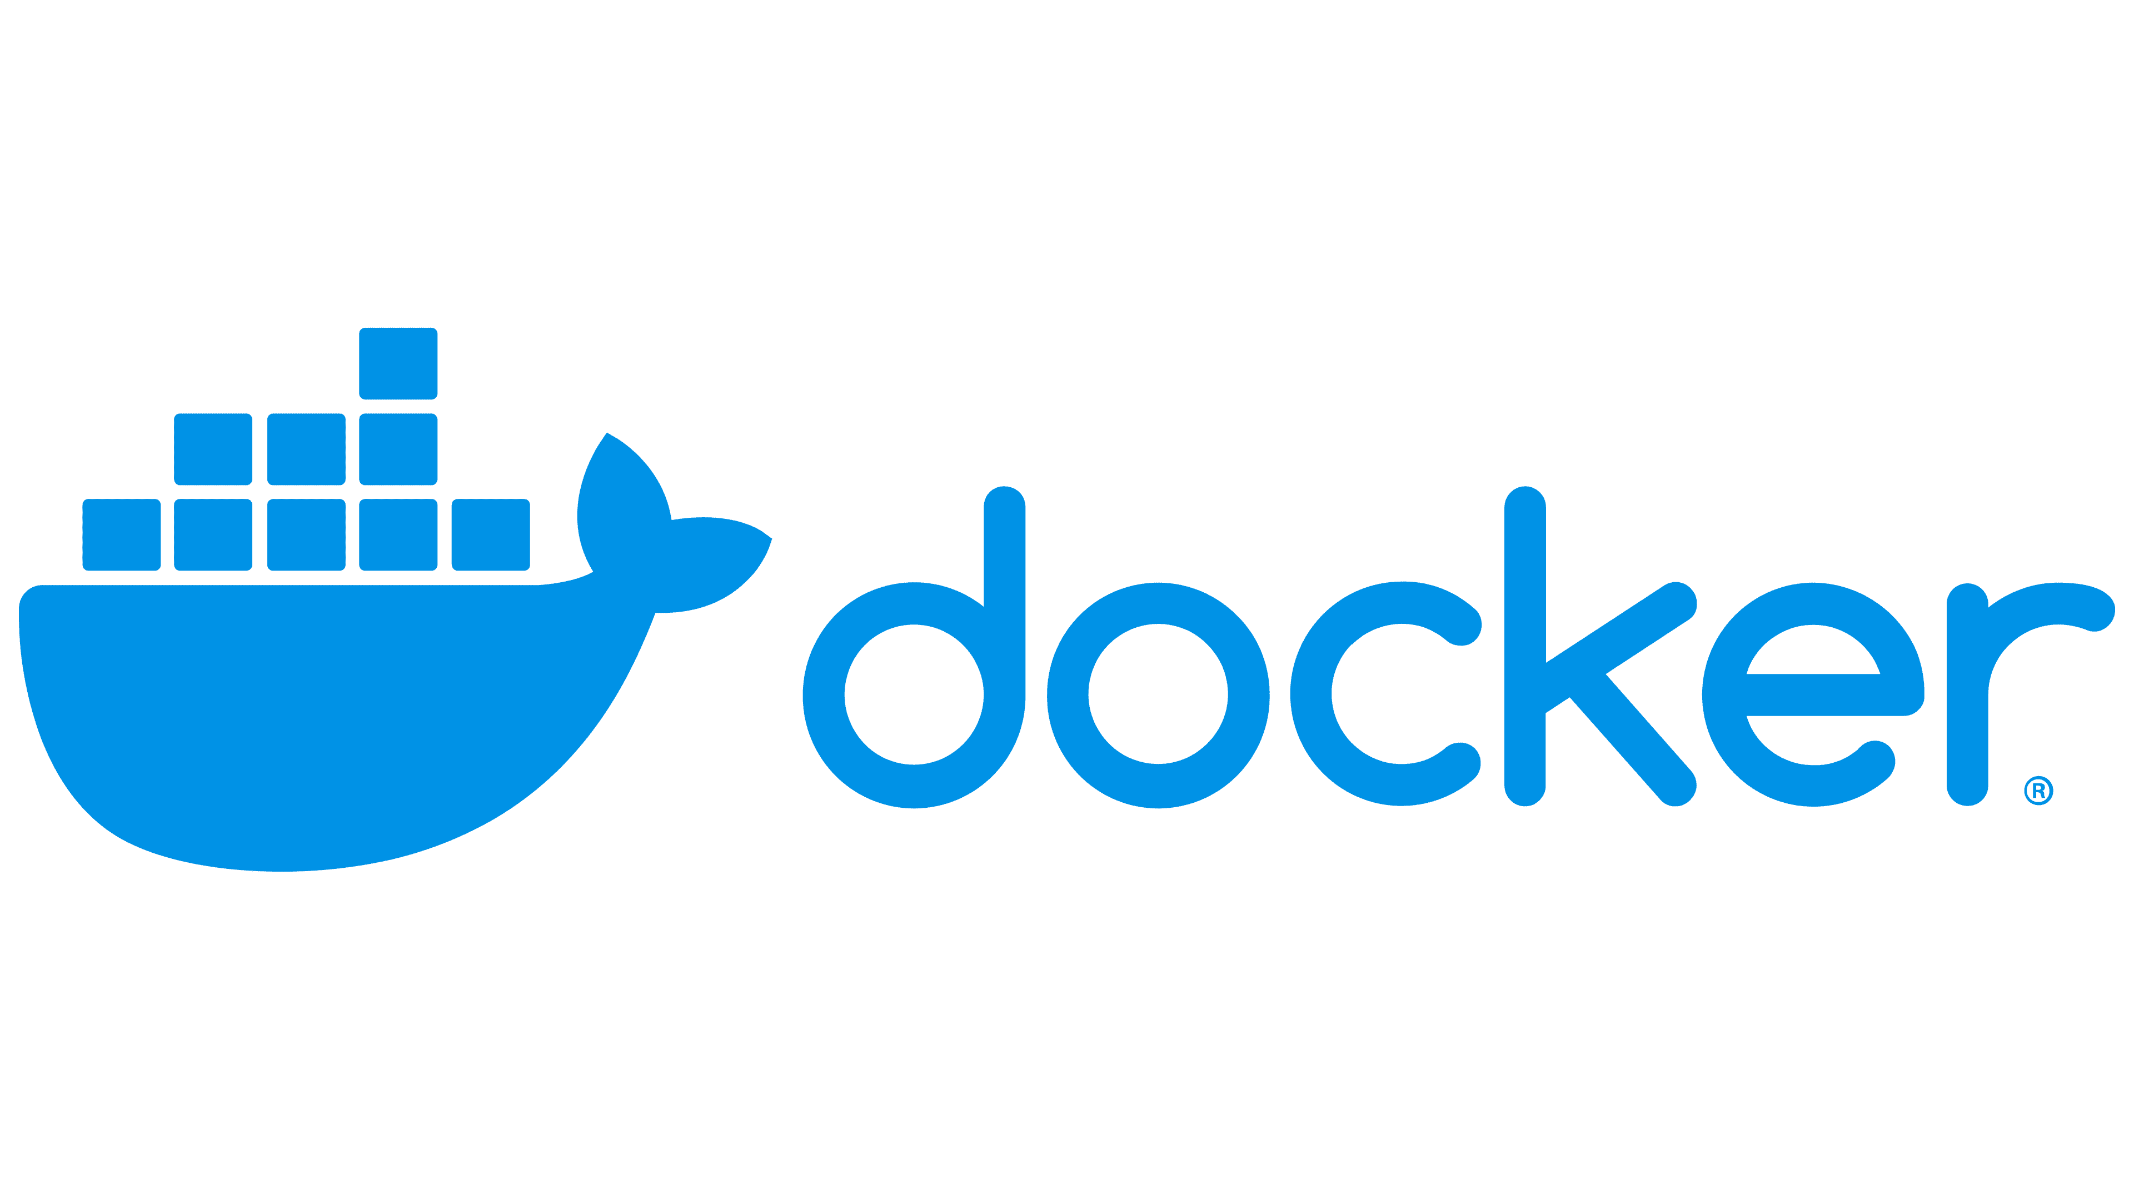

## **Docker**

**Advantages:-**

* **Versatility:** Because containers may run on any platform that is compatible with Docker, consistency between development, testing, and production environments is ensured**.**
* **Separation:** Containers provide separate environments, helping to reduce conflicts and boost security (DuploCloud, 2023).
* **Efficiency:** They also use resources more efficiently than traditional servers since multiple containers can share the same OS kernel.

**Disadvantages:-**

* **Intricacy:** Setting things up and learning how it works can be complicated at first, which is a downside
* **Coordination Requirements:** Managing multiple containers can get complicated without tools for coordination.

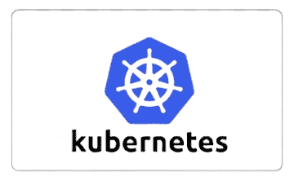

## **Kubernets**

**Advantages:-**

* **Scalability**: Distributes workloads, handles scaling, and maintains high availability automatically.
* **Automatic Recovery:** Identifies and swaps out malfunctioning containers to keep the program running.
* **Service Locator:** Finding and connecting to services within a cluster is made easier with the help of service discovery.
* **Load Blancing:** To guarantee that no one instance of a service is overloaded, load balancing divides traffic among several instances (Harsh, 2021).

**Disadvantages:-**

* **Intricacy:** Setting things up can be intricate, with a steep learning curve at first. You need some knowledge to manage it well.
* **Resource Consumption:** Kubernetes needs its own resources to run, which might be too much for smaller applications.
* Of all the deployment techniques mentioned above, **Kubernetes is the most suitable** for Debra Event. Here is the reason
* **Scalability and Flexibility:** Kubernetes offers automated scaling, which is essential for Debra's event management system since it can handle different loads based on event popularity and sales periods.
* **Resource of Efficient Utilization:** Kubernetes efficiently manages resources by distributing workloads across multiple nodes and containers, making it a more cost-effective option than traditional server deployment.
* **Resilience:** Kubernetes' self-healing and high availability features ensure the system stays operational even if some components fail. This is crucial for managing ticket sales and real-time events
* **Service Integration:** The ability to easily integrate with other services, such as social media platforms and mobile apps, aligns well with Debra's requirement to expand system functionalities and partner integrations.

## **Comparison with other deployment techniques mentioned**

* Traditional Server Deployment would be difficult to manage as the system grows, needing constant manual attention.
* While Docker Containers offer good isolation and resource efficiency, they lack the automated orchestration and management capabilities necessary for a complex, scalable application.

In conclusion, Kubernetes is the best deployment choice for Debra's SOC-based application because of its scalability, fault tolerance, and efficient resource management. These qualities make it ideal for a dynamic and expanding event management system.

# References

D., A. & Dmytro H., 2019. *rubygarage.* [Online]   
Available at: https://rubygarage.org/blog/monolith-soa-microservices-serverless  
[Accessed 30 06 2024].

DuploCloud, 2023. *duplocloud.com.* [Online]   
Available at: https://duplocloud.com/blog/docker-advantages-and-disadvantages/  
[Accessed 10 07 2024].

Harsh, K., 2021. *scoutapm.com.* [Online]   
Available at: https://scoutapm.com/blog/kubernetes-advantages-disadvantages  
[Accessed 10 07 2024].

ramtechpcs, n.d. */www.ramtechpcs.com.* [Online]   
Available at: https://www.ramtechpcs.com/services/server/  
[Accessed 10 07 2024].